**IMPACT OF SOCIAL MEDIA USER GENERATED CONTENT (UGC) ON ONLINE PURCHASE INTENTION****: WITH SPECIAL REFERENCE TO RETAIL FASHION INDUSTRY, IN SRI LANKA.**

Research

By

M.P.T.S. Madhuranga.

BM/2017/243

Department of Marketing Management

Faculty of Commerce & Management Studies

University of Kelaniya Academic

Year 2017/18

**DECLARATION**

This research project report is submitted to the Department of Marketing Management of University of Kelaniya as a partial fulfillment of the Bachelor of Business Management (Special) Degree in Marketing. I hereby certify that this research is conducted in my own account with the help of a survey done and data collected by me without any unethical use of any document and publication. Further, I declare that this research project has not been submitted previously for any professional qualification program at any educational institution. In the event, I have used conceptual material or work of others, which gave me the knowledge and foundation to conduct this study, I have to the best of my knowledge given the parties due acknowledgment for adapting such material and due reference is made in the text.

Signature –

Name - **Madhuranga M P T S**

Student No - **BM/2017/243**

17th of December 2022

**CERTIFICATION OF THE SUPERVISOR**

This is to certify that Madhuranga M.P.T.S (BM/2017/243) has completed this research under my supervision and that he has fulfilled necessary requirements. Hence this dissertation is qualified to be submitted for the Bachelor of Business Management (Marketing) Special Degree of University of Kelaniya, Sri Lanka.

…………………………… …………………………..

Research Supervisor Date

Senior Lecturer Thilina Karunanayake

Department of Marketing Management

Faculty of Commerce and Management Studies

University of Kelaniya

Sri Lanka

**ACKNOWLEDGMENT**

I would like to express my gratitude wholeheartedly to my supervisor senior lecturer Mr. Thilina Karunanayake of Department of Marketing Management, University of Kelaniya for his constant support to conduct this research study. Further, I would also like to extent my gratitude to all the Lecturers, staff members of the Department of Marketing Management, for their continuous support and encouragement given for final year undergraduates to successfully complete their dissertations. Special thanks goes to my beloved batchmates of final year, who continuously supported me.

**TABLE OF CONTENTS**

**1 INTRODUCTION 12**

**1.1 Background of the study 12**

**1.2 Industry Overview 15**

**1.3 Research problem and justification 17**

**1.3.1 Literature gap 17**

**1.3.2 Practice Gap 20**

**1.4 Research Problem Statement 22**

**1.5 . Research Objectives 24**

**1.6 . Research Questions 25**

**1.7 . Significance of the Study 26**

**1.8 Overview Of Research Methodology 27**

**1.8.1 Introduction 27**

**1.8.2 Scope of the Study 27**

**1.8.3 Sources of Data 28**

**1.8.4 Sampling plan 28**

**1.9 Limitations of the Study 29**

**1.10 Chaptalization 30**

**2 . LITERATURE REVIEW 31**

**2.1 Introduction 31**

**2.2 Overview of Social Media User Generated Content 31**

**2.2.1 Social Media User Generated Content 31**

**2.2.2 The power of Social Media User Generated Content. 32**

**2.2.3 Types of social media user generated contents 34**

**2.3 Perceived Usefulness 35**

**2.4 Perceived Risk 36**

**2.5 Instagram 38**

**2.6 Facebook 39**

**2.7 Overview on Online Purchase Intention 40**

**2.8 Relationship of Social Media User Generated Contents and Online Purchase Intention 41**

**Conceptuali zation 42**

**3 OPERATIONALIZATION & METHOTOLOGY 42**

**Conceptualization 42**

**3.1 Introduction – Conceptualization 42**

**3.2 Conceptual Framework 43**

**3.3 Development of Hypothesis 43**

**3.3.1 Perceived Credibility and online purchase intention 44**

**3.3.2 Perceived Usefulness and online purchase intention 44**

**3.3.3 Perceived Risk and online purchase intention 45**

**3.4 Introduction – Operationalization 46**

**3.5 Operational Definitions 48**

**3.5.1 Social Media User Generated Content 48**

**3.5.2 Perceived Credibility 48**

**3.5.3 Perceived Usefulness 48**

**3.5.4 Perceived Risk 48**

**3.5.5 Online Purchase Intention 48**

**3.6 Introduction 49**

**3.7 Research Philosophy 49**

**3.8 Research Design 50**

**3.8.1 Unit of Analysis 51**

**3.8.2 Sampling procedure 52**

**3.9 Method of Data Collection 54**

**3.9.1 Primary Data 54**

**3.9.2 Secondary Data 55**

**3.10 Questionnaire development 55**

**3.11 Scaling 56**

**3.12 Data analysis techniques 56**

**3.12.1 Descriptive statistics 56**

**3.12.2 Inferential Statistics 57**

**3.13 Chapter Summary 57**

**4 DATA PRESENTATION AND ANALYSIS 59**

**4.1 Chapter Introduction 59**

**4.2 Data Preparation for Analysis 59**

**4.2.1 Missing Values 59**

**4.3 Descriptive Data analysis 61**

**4.3.1 4.3.1. Frequency distribution analysis of respondents by their personal characteristics 61**

**4.3.2 Descriptive distribution analysis for variables 74**

**4.4 (Validity) Test 75**

**4.4.1 (Reliability) Conbranches’ Alpha 76**

**4.5 Multivariate Assumptions 77**

**4.5.1 Normality 77**

**4.6 Correlation Coefficient Analysis 81**

**4.7 Multi Co-linearity Test 83**

**4.8 Multiple Regression Analysis 84**

**4.9 Hypothesis Testing Result 87**

**4.10 Chapter Summery 89**

**5 CONCLUSION AND RECOMMENDATIONS 91**

**5.1 Introduction 91**

**5.2 Summary of Research Study 91**

**5.3 Research Problem Statement Achievement 91**

**5.4 Discussions and Findings 92**

**5.4.1 Findings of Perceived Credibility 94**

**5.4.2 Findings of Perceived usefulness 94**

**5.4.3 Findings of Perceived Risk 95**

**5.5 Conclusion 95**

**5.6 Contribution of the Study 96**

**5.7 Recommendations 97**

**5.7.1 Theoretical Implications 97**

**5.7.2 Managerial Implications 99**

**5.8 Suggestions for further research 99**

**6 REFERENCES 100**

**7 ANNEXURES 120**

Figure 1: Sales revenue increasing percentage behaviour 19

Figure 2 : Conceptual Framework 40

Figure 3 : Sample Size Calculation 50

Figure 4 : - Analysis of content refer platforms 59

Figure 5 : Analysis of mostly prefer retail fashion store, to purchase fashion products online 60

Figure 6 : Analysis of retained time period with the mentioned brand 61

Figure 7 : Experiences regarding refer to Social Media User Generated Contents (UGC), before taking a purchase decision in fashion retail products 62

Figure 8 : Analysis of frequently content refer platforms 63

Figure 9 : Analysis about mostly considering content type 64

Figure 10 : Gender composition 65

Figure 11 :Area Analysis 66

Figure 12 : Age Analysis 67

Figure 13 : Employment Analysis 68

Figure 14 : Education Level Analysis 69

Figure 15 : Marital Status Analysis 70

Figure 16 : Income Level Analysis 71

Figure 17 : p-p plot of regression standardized residual 78

Table 1: Sri Lanka Revenue change Statistics 19

Table 2 : Operationalization Table 44

Table 3: Missing values 58

Table 4 : Analysis of content refer platforms 59

Table 5 : Analysis of mostly prefer retail fashion store, to purchase fashion products online 60

Table 6 : Analysis of retained time period with the mentioned brand 61

Table 7: Experiences regarding refer to Social Media User Generated Contents (UGC), before taking a purchase decision in fashion retail products 62

Table 8: Analysis of frequently content refer platforms 63

Table 9: Analysis about mostly considering content type 64

Table 10: Gender composition 65

Table 11: Area analysis 66

Table 12 : Age analysis 67

Table 13 : Employment Analysis 68

Table 14: Education Level Analysis 69

Table 15: Marital Status Analysis 70

Table 16: Income Level Analysis 71

Table 17: Descriptive Statistics 72

Table 18: KMO and Bartlett's Test 74

Table 19 : Cronbach’s Alpha table 74

Table 20 : Skewness and Kurtosis 76

Table 21: Correlation table 79

Table 22: VIF and Tolerance values of multiple linear regression mode 81

Table 23 : Multiple linear regression 82

Table 24: Model Summary 84

Table 25: ANOVA 84

Table 26: Result of Testing the Hypothesis 85

In this research study, following short terms will be used to define the each mentioned terms.

UGC- User Generated Contents

PC - Perceived Credibility

PU – Perceived Usefulness

PR – Perceived Risk

**ABSTRACT**

Online purchasing has become a crucial concept in the world. When it comes to Sri Lankan retail fashion industry, approximately online sales values are increased. But the challenge is, there is a reduction of sales increasing percentages over a few years. As forecasted, this cycle will happen for next year as well. Meanwhile, Facebook, Instagram usage and content creation have increased. Those (UGC) contents are used to share customers’ experiences. This type of content affects customers purchasing decisions. Based on the limited literature study about UGC as a separate factor, it is essential to investigate the related issue to examine the impact of social media user-generated content (UGC) on online purchase intention: with special reference to retail fashion industry, in Sri Lanka. Based on various studies, a research model was developed. Thus, this research has been done as a quantitative research design and deductive approach. A Structured questionnaire has been used to collect data from the sample which is female and male Facebook and/ or Instagram users in the western province, Sri Lanka. 220 respondents have used as the sample and it is based on non-probability, convenient sampling. Data presentation and analysis have been done according to descriptive analysis, correlation and regression analysis. Statistical package for social science (SPSS) has been used as the analytical software. The findings demonstrate a positive, significant impact of perceived credibility, perceived usefulness, perceived risk in each dimension on online purchase intention. Therefore, with this study, it was possible to identify the impact of social media UGC on online purchase intention and its contribution to understand the importance of enhancing social media strategies and managing social media UGC as an effective tool.

***Keywords:*** *Online purchase intention, Perceived credibility, Perceived risk, Perceived usefulness, Social media user generated content.*

**CHAPTER 01**

# INTRODUCTION

## Background of the study

The background of the study use to explain the concept of Social Media User Generated Content and the concept of Online Purchase Intention in retail fashion industry in SL. Therefore, the purpose of this study is to synthesise the findings of existing research on social media user-generated content (UGC) on online purchase intention in the context of fashion retail and to come up with future research directions.

Today's digital era, social media facilitates communication not just among consumers themselves but also between brands and consumers ( Quach and Thaichon, 2017). Such “various forms of media content that are publicly available and created by end-users” are defined as UGC (Haenlein and Kaplan, 2010). Marketers tend to know customer purchase decisions and behaviour which related with social media developments. customers try to use those things when they are getting

purchasing decisions about their needs (Kim & Rao, 2008; Kim J. , 2013; Hazari, Bergiel, & Sethna, 2016). When it comes to social media usage, it is increased than other media usage and people are willingness to have an idea before going for shopping (Hajduk, 2018). If organization has online / social media marketing strategies, they can easily achieve what they want (chiang & kevin, 2019). There are many benefits with social media related to cost, availability, contacts (Doherty & Ellis, 2018). If the company have already a shop and if they tend to have online customers, its effective when it compares (Barsh, Crawford, & Grosso, 2020). Consumer behaviour is important to study in online which has a good connection among people when they are using those platforms ( Chan & Li, 2010).

According to Kemp (2021), they assume there can be an increase of internet users in Sri Lanka in 2022. The amount can be 7.4% as it assumes. The main consideration is most of the western province people are in the active user’s category. its province people are in the active user’s category. when it comes to Sri Lanka 7.9 million people can consider as active social media users in January 2021. The prediction is there can be a social media user increase (by 23%) in SL in 2020 to 2021. 36.8% social media users can be identified as the percentage by the total population. Using social media platforms become a daily habit in the present digital context. Sri Lanka has 8.20 million active social media users which is 38.1% of the total population while 7.15 million used Facebook in early 2022. According to Kepios analysis, this social media users statistic in SL have increased by 3.8% from 2021 to 2022 (Kemp, Digital-2022; Sri Lanka, 2022). This means, social media users have increased. Thus, When it comes to October,2022, active Facebook users in sri lanka is 82.81 %. Instagram active users are 1.55% in SL. As main two platforms Facebook and Instagram use by Sri Lankans (statcounter.com, 2022). After 2020, there is an increasing regarding user generated content creations on social media about Sri Lankan customer’s experiences about fashion products which is a new habit to Sri Lankans as an impact of Covid lockdowns ( Gopura & Indumini, 2021). The social media user generated contents have been identified as the independent variable for this study. For this study, what researcher consider as social media platforms in order to investigate the user generated contents is, **Facebook & Instagram.**

It is active social media users can see and active generators can see. those tend to share their information about consumption and other related things quickly (Resnik & Koklič, 2018). customer feedbacks can gather with this social media development in the world. This will be a plus point for companies. ( Mangold & Faulds, 2009). If it is a negative thing, there can be an identification to have some developments in companies. Now adays brands tend to use social media as a marketing channel (Aronald, 2018). 70% of People prefer to log in to social media when they are taking purchasing decisions and some users tend to use what they found in order to buy their needs (Deiworldwide, 2008). The important thing is people tend to use social media reviews as a guide for purchase (Wijesundara & Thilakarathne, 2017).

In fashion retail industry, customers use social media blogs, reviews like things use to share and have a discussion about their experience and reviews (Mannan & Rahman, 2018). Print media used before to find information and updates ( Sherman, Hernandez, Greenfield, & Dapretto, 2018). People consider fashion as a main need of themselves. when it comes to Sri Lankan fashion industry, retailors are doing more roles including designing like things. this is a good improvement (Ranaweera & Halwatura, 2014; Dias, 2011). There can be see a good development in fashion retail industry. one is cultural changes in the country, and it allows to do more fashion. economically also can see an impact to do fashion. Customers tend to use reviews and vlogs before have a purchase decision about retail fashion ( Ramirez, Gau, Hadjimarcou , & Zhenning, 2018). Social media UGC can be used to have more customer interactions with customers (Bala & Ray, 2021). When it comes to social media UGC it is different thing in technology and distribution. (Burmann, 2010). It’s possible to have more discussions about customer experience in social media to have a good preference in retail fashions selection ( Ramirez, Gau, Hadjimarcou , & Zhenning, 2018). Companies should understand how social media UGC can use to have a good engagement and relationship ( Ukpabi & Karjaluoto, 2018).

Further, 74% of consumers are believing on social networks to get help with their purchasing decisions (Garvin, 2019). According to the Ewing (2019) 71% of consumers are more likely to make purchases based on social media UGC that they found. And in an online shopping market study showed that social media UGC, price and business's reputation were three key factors for online shopping decision-making in China, with the attention level of information reaching 77.5%, 72.2% and 68.7% respectively. Therefore, The Important thing is, social media UGC is the major factor that consumers influence in online purchase intention. (CNNIC, 2018; Zhu , Li , Wang , He, & Tian , 2020).

When it comes to Sri Lankan fashion retail industry, the percentage of the increased revenue in this context is reducing. When it elaborate more, there was increases in fashion retail online sales in Sri Lanka from 2020-2021 and 2021-2022 also. But, its percentage of increased amount is reducing. In the end of 2020, there was a 47.6% increase than 2019 year in the online fashion retail sales in SL. After that, in the end of 2021, there was a 25.1% increase than 2020 year. Although it is an increase, increased percentage is reducing. As they forecasted, this situation is going to happen same for the 2022 as well. It can be consider as the main issue in this context in SL why it is reducing the revenue increasing percentage over few years (Statista, 2022). Bahtar & Muda (2016) suggested a framework in order to investigate the impact of social media User Generated Content on online purchase intention. Based on that, Perceived credibility, Perceived usefulness and perceived risk will be used as the variables in this study.

Therefore, this research is planned to identify, does there an impact of social media UGC on reduction of the Sales Revenue increasing percentage’s reduction that researcher have identified by considering social media UGC as the main factor .Its main consideration to identify the impact of Social Media user generated content on online purchase intention in fashion retail industry in Sri Lanka. This is worth to investigate.

## Industry Overview

**Fashion history** is coming to the world not in an instant. it has a time to time development. when the world began and human being become as a developed animal with evolution, they used to wear some cloths. from that point onwards, human tried to do fashion unconsciously. but it was not like this era. they used natural things such as leaves, some parts of leaves, skins of tiger like wild animals but now it has a development and it became as a main need and most of the times it exceed the basic need, with the development of digital media, people tend to purchase fashion products online. (fashionhistory timeline, n.d.). **Fashion retail** can define as, a main thing which connect as a bridge. final customer and manufacturer connect with this system. retailors try to collect and have more fashions in their outlets which is in online or offline, their duty is to provide final fashion output which is produced by a manufacturer to an end customer. (textilelearner, n.d.). In fashion retail it includes, apparels, footwear, luggage and bags watches and jewellery, accessories**.** people tend to use amazon like platforms to purchase fashions. Asos, Zalando like online fashion retailors also getting famous in Sri Lanka (Statista, n.d.).

Recent position of fashion retail industry is not an easy thing. it has volatile demand for fashions and time to time it get varying. because customers are not like before. they have a good sense with social media, and they have a new habit to find information about their future buying products and what is the experience of existing consumers like things. they try to evaluate those with comments, reviews like UGC. their demand change because they have more expectation than what provide by retailor. their main consideration is personalised fashion retail service in online as well. (Giri, Thomassey, & Zeng, 2018).

Most of us, especially the ladies, enjoy shopping in their favourite clothing stores, shops, and boutiques. Fashion wear industry can consider as one of the lucrative and a lively industry globally. The fashion industry is a highly growing industry in Sri Lanka. Everyday fashion retail outlets are being opened but only a handful of them are successful. The fashion industry contributes to approximately 3 trillion dollars and it is 2% of the world’s gross domestic product. When it comes to Sri Lanka, retail sector is a quickly developing industry and has a high potential to do well (Group O.B, 2017). Out of the retail sector, the fashion wear retailing takes a huge amount of 39% and has a high potential to develop in the future. When it comes to the fashion wear retailing, it is greatly esteem basing on the high brand resources.

Online fashion retail industry is now fast-growing thing in the world. in UK they had a 60% amount of online fashion retail sales when it compared to all fashion retail sales in UK at the time of it measuring. However, with the privilege situation of the world it is declining the sales with the problem of purchasing power. but it hopes a hit $ 672.71 Billion by 2023. but most of the people try buy at least less amount of fashion products through online rather than go for offline purchasing with the situation (Orendrff, 2021). In global it has an online fashion share revenue. it is near to 23% in 2020. In Asia like regions, it is having a development of online fashion purchases. Instagram checkout like modern trends are spreading as a up to date thing and this help to have more purchase intention in online (Statista, n.d.). There is a reduction of the revenue increasing percentage of the selected context in Sri Lanka. Although it has an increasing sale in fashion retail industry, sales revenue increasing percentage is getting low over few years in Sri Lanka and reporters have forecasted this sales revenue increasing percentage reduction will happen in 2022 as well. This is the main issue in this context (Statista, 2022). In Sri Lanka, there are few main fashion outlets dominating the retail fashion industry after 2020. Those brands are using customers for online purchases ( Gopura & Indumini, 2021). Those are like follows,

* ODEL
* GFlock
* Chenara Dodge
* Moose Clothing
* Thilakawardhana
* Nolimit
* Fashion Bug
* Kelly Felder

When it comes to sri lanka As steady with 2013 international retail development index, Sri Lanka titled as “thriving with smooth investment ranks fifteenth with a market beauty of 16.6 %” (Kearney, 2013). Sri Lanka’s retail location ranking. in keeping with the A.T Kearney Global Retail Development Index leap fogged to 12 in 2017 (Dailynews, 2017). steady and the entire retail earnings amount in Sri Lanka for 2017have become US$30. In Sri Lanka’s fast growing retail area, fashion-fashion retailing represent a large portion (39%) showing a wonderful possibility to boom in future (Kamburugamuwa, 2015). Its presentations that fashion retail agency is a growing quarter In Sri Lanka. And there was a risky situation with the pandemic. but in online fashion retail industry, assumption is to achieve US$602 Million worth revenue in next 2022 year. The main thing is, 19.64% growth rate need to achieve in this year in the context .in this industry, it assumes to have at least US$ 130.25 expense in online fashion retail by a one shopper. online fashion retail users also need to achieve up to 6.3 Million in SL. it hope to have in 2025. (Statista, n.d.) In fashion retail industry customers , they try to have an understanding about other customers opinions by referring SM UGC as a habit . This will be a challenge for online retail industry

## Research problem and justification

**Research Gap**

### Literature gap

In an online shopping market study showed that social media UGC, price and business's reputation were three key factors for online shopping decision-making in China, with the attention level of information reaching 77.5%, 72.2% and 68.7% respectively. Therefore, in that study, researchers highlighted social media UGC is the main & important factor that can have an impact on online purchase intention as they identified and this social media UGC should take separately by considering the independent variable in order to study more about its impact on online purchase intention in future studies (CNNIC, 2018; Zhu , Li , Wang , He, & Tian , 2020). Therefore, there is a gap to study social media UGC separately in order to study its impact more towards social media UGC.

It’s a gap which need to find, how SM UGC can use to influence customers for their buyer decisions and attract, retain or push away consumers ( Barrot, Becker, & Meacker, 2018; Wali & Adanne , 2018; Mills & Plangger, 2020; Lancaster, Helal, & Ozuem, 2018).

Customers can have a need to find information of other customers purchasing experiences with offline through friends or online through social media user-generated content platforms like online brand communities in order to find how it impact to other decisions ( Ilic, Juric, Brodie, & Hollebeek, 2013).

UGC can find as a mostly using thing although some people have less knowledge and don’t know how to use it as well (Dennhardt, 2018). Most research done studies are to find about motivators and how that impact to create UGC about their experience (Kim & Park, 2017).

It is a gap to study, to find the reasons for willingness of creating UGC on social media. Not only that , there is a gap to find how social media UGC can impact as an information provider before the purchases (Verhelle, Dens, & Pelsmacke, 2013; Poch & Martin, 2015).

Many studies done for other contexts. mainly in corporate mobile data context ( Neal & Rose, 2018), Also, most studies were conducted to explore the impact of UGC on corporate mobile media ( Neal & Rose, 2018), travelling and planning (Konstantina, 2018), and as an advertisement tool on television shows (Viswanathan et al, 2018)Such studies have highlighted that it is important to understand how social media UGC can encourage social interaction between brands and consumers to improve consumer-brand relationship/engagement ( Ukpabi & Karjaluoto, 2018).

There can be see a need to study how social media UGC impact as a social influence factor in fashion context ( Ramirez, Gau, Hadjimarcou , & Zhenning, 2018; Halliday, 2018). When it comes to main researches that have done, those all are going with cosmetic like industries ( Isyanto, Sapitri, & Sinaga, 2020). There is a suggested future study to know, how the impact of UGC in fashion industry like main industries and it recommend a need to study and understand, how would be the impact when people are purchasing online ( Karunanayake & Madubashini, 2019).

It’s a gap to study the impact of social media UGC considering as a social influencing factor (Maecker, Barrot, & Becker, 2016) Furthermore, Ramirez, Gau, Hadjimarcou , & Zhenning (2018), also recommended looking at social motivational causes of social media UGC that can create brand stories and WOM as key sources to create and enhance social influence in terms of SBE. Therefore, there is a need to determine who exerts social influence and how they exert social influence through the social interaction of social media UGC.

There can be see a need to study the engagement and customer relationships and how it can have an impact with social media UGC ( Ukpabi & Karjaluoto, 2018). It has a need to study how social media UGC impact as a motivational reason of social media UGC. positive WOM like things also should need to find how it will impact. UGC is a persuasion factor which convert people mindset to do some purchases ( Ramirez, Gau, Hadjimarcou , & Zhenning, 2018). This means, it is a gap to study about this social influencing reasons by social media UGC.

It is a good thing in social media UGC in fashion industry. that UGC will help customers to identify other experiences and their findings. Researchers have argued that brand-related UGC among social media users creates more awareness about new trends and fashions ( Ramirez, Gau, Hadjimarcou , & Zhenning, 2018).

There can be identify a need to explore the extent to which SMUs trust UGC and how social media UGC effects the social interactions of SMUs to create further content more effective, the social factors of UGC, consumers’ motivation to share their all related experiences, and consumers’ brand engagement are not understood well . Moreover, mentioned in their study that there can be identify a need to understand the different social factors of social media UGC and SMUs’ brand engagement ( Ramirez, Gau, Hadjimarcou , & Zhenning, 2018; Naeem & Ozuem, 2020).

There is little understanding which is related with the various reasons social media users create, post, share and exchange UGC on social media and how/why they get influenced by each other related to fashion brands in the industry. Most of the existing literature are focussing to investigate the relationship between social media and fashion brands in a more general context, such as social media impact on customer decision making ( Bilal, Ahmed , & Naveed , 2020), personality, quality, and prestige-related things (Tatar- & Erdogmus, 2016). usage of social media networks for particular brand-related contents; and power of consumers as ability to make pressure on brands ( Kim & Johnson, 2016).

### Practice Gap

When it comes to fashion industry it can identify as the one of the most profitable and vibrant industry in the world. And the special thing is, it is worth around 3 trillion dollars and accounts for 2% of global GDP (Fashion United Group, 2017). When it comes to retail sector in Sri Lanka is rapidly growing sector (oxford business group, n.d.). Fashionwear retailing accounts for a considerable share of this business (39%) and there is a lot of room for growth in the future (Kamburugamuwa, 2015).

Online platforms such as blogs, customer's social media online reviews, and social networking websites are consumers to find, discuss and share information regarding various aspects of fashion clothing and all become increasingly significant to fashion public relations as a considerable thing ( Ramirez, Gau, Hadjimarcou , & Zhenning, 2018).

When it comes to past researches, 70% of consumers visit social media sites to gather information, 49% of these people take a buying decision based on the information that they found through social media sites (Deiworldwide, 2008). 74% of consumers are believing on social networks to get help with their purchasing decisions (Garvin, 2019). According to Ewing (2019) 71% of consumers are more likely to make purchases based on social media referrals that they found.

According to Statista (2021), considerable online fashion sector was worth over $439 billion in 2018, by 2024, this astonishing sum is forecast to more than quadruple ($953 billion), and it is currently expected to achieve $753 billion target in 2020 and $898bn in 2021, further, sectors like clothes, accessories, and footwear, which are predicted to account for 32.8 percent of all fashion eCommerce sales by 2024, are driving this important rise in the context.

According to recent statistics of the fashion industry, as the years' progress from 2021 to 2024, All people in SL also hope to see an important increase in the penetration rate and channel share of the fashion market. The real scenario is it is with an increase to all three of the main sectors. Not only that in fashion e-Commerce in general. And by the end of 2021, online channel share is expected to reach the amount to 22% of the fashion market sales worldwide, whilst the fashion industry e-commerce penetration rate is expected to hit 50% ( Christian, n.d.; Statista, 2021).

But, according to the researcher findings, although that there was a revenue increase than previous years when it compare two years, the percentage of the increased revenue in this context is reducing. When it elaborate more, there was increases in fashion retail online sales in Sri Lanka from 2020-2021 and 2021-2022 also. But, its percentage of increased amount is reducing. In the end of 2020, there was a 47.6% increase than 2019 year in the online fashion retail sales in SL. After that, in the end of 2021, there was a 25.1% increase than 2020 year. Although it is an increase, increased percentage is reducing. As reporters forecast this situation is going to happen same for the 2022 as well. It can be show as follows and this is the main issue in this context in SL why it is reducing the revenue increasing percentage over few years (Statista, 2022).

Table 1: Sri Lanka Revenue change Statistics

|  |  |
| --- | --- |
| **Year** | **Revenue Change (Online Fashion retail ) in Sri Lanka Percentages** |
| 2020 | 47.6% |
| 2021 | 25.1% |
| 2022 | 11.8% |

Source : (Statista, 2022)

This reduction of sales increasing percentage in Sri Lankan fashion retail industry over few years is exhibit graphically in Statista (2022) as follows, And the 2022 sales revenue value is a forecasted value as they highlighted.

Figure 1: Sales revenue increasing percentage behaviour

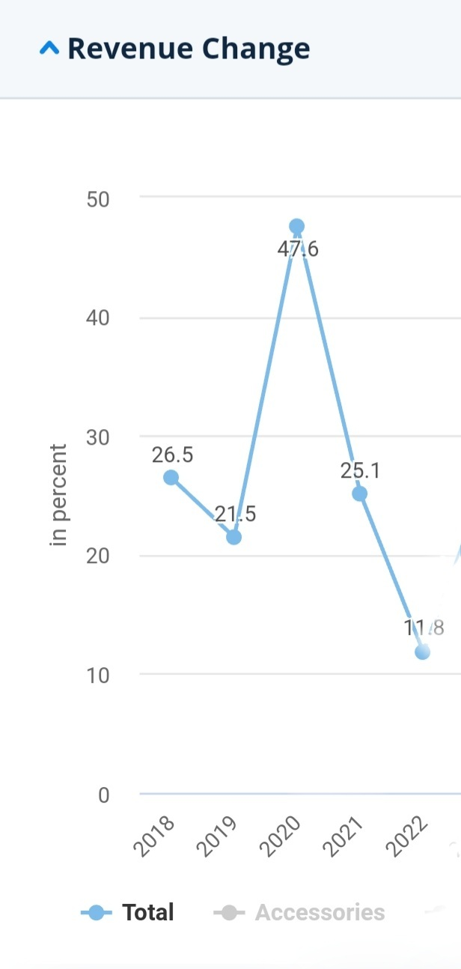

Source : (Statista, 2022)

When considering the above problem, this particular research study is focusing on fashion retail products’ customer purchase intention, there can be seen a gap well. As previous research study revealed, social media user generated content has impact on online purchase intention as a special thing.

## Research Problem Statement

To address those found gaps in the research scope and practice gap, the researcher intends to conduct the research on investigating the impact of social media user generated content on online purchase intention of the retail fashion industry context. There is **a reduction of the revenue increasing percentage** of the selected context in Sri Lanka. Although it has an increasing sale in fashion retail industry, sales revenue increasing percentage is getting low over few years in Sri Lanka and reporters have forecasted this sales revenue increasing percentage reduction will happen in 2022 as well. If it is elaborate more, although that there was a revenue increase than previous years when it compare two years, the percentage of the increased revenue in this context is reducing. When it study more, there was increases in fashion retail online sales in Sri Lanka from 2020-2021 and 2021-2022 also. But, its percentage of increased amount is reducing. In the end of 2020, there was a 47.6% increase than 2019 year in the online fashion retail sales in SL. After that, in the end of 2021, there was a 25.1% increase than 2020 year. It is a huge issue if it is going to happen the same for next years as well (Statista, 2022)*.*

Customers are the main party that involving in generating sales revenues. When it comes to sales issues, its optimum to investigate on purchase intention through customer perspective in order to identify the proper solution ( Zhu , Li , Wang , He, & Tian , 2020). Thus, how this connects with social media user generated contents is, there is an increase (by 3.8%) regarding Sri Lankan social media active users in 2022 from 2021 (Kemp, Digital-2022; Sri Lanka, 2022). It means throughout 2021, active social media users have increased in SL. Further, Facebook active users are 82.81% and Instagram active users are 1.55% in October 2022 (statcounter.com, 2022). After 2020, there is an increasing regarding user generated content creations on social media about Sri Lankan customer’s experiences about fashion products ( Gopura & Indumini, 2021). Therefore, the consideration is, why this sales revenue increasing percentage have decreased, if there was an increase about Social media users in SL, increasing user generated content creations in the context.

Further, in an online shopping market study showed that social media UGC, price and business's reputation were three key factors for online shopping decision-making in China, with the attention level of information reaching 77.5%, 72.2% and 68.7% respectively. Therefore, in that study, researchers highlighted SM UGC is the main & important factor that can have an impact on online purchase intention as they identified and this social media UGC should take separately by considering the independent variable in order to study more about its impact on online purchase intention in future studies (CNNIC, 2018; Zhu , Li , Wang , He, & Tian , 2020). Therefore, this research is planned to identify, does there an impact of Social Media UGC on the revenue increasing percentage’s reduction in customers’ perspective that researcher have identified by considering social media UGC as the main factor. This research is proposed to be conducted in western province, Sri Lanka by using quantitative data collection and analysis methods.

**Accordingly, decided research Problem is, How does social media** **user generated content impact on online purchase intention in the fashion retail industry with special reference to Sri Lanka.**

## . **Research Objectives**

In this research study, primary objective is to evaluate the impact of social media UGC on online purchase intention is the overall objective. Based on that, Researcher have identified three main objectives to investigate in this study.

1. To examine the impact of Perceived Credibility on online purchase intention: special reference to retail fashion industry, Sri Lanka.
2. To examine the impact of Perceived Usefulness on online purchase intention: special reference to retail fashion industry, Sri Lanka.
3. To examine the impact of Perceived Risk on online purchasing intention: special reference to retail fashion industry, Sri Lanka.

## . Research Questions

The researcher attempts to evaluate the direct impact of social media UGC on purchase intention, based on the defined research problem. Accordingly, researcher develops research questions to have a good understanding and represents the impact of social media UGC on purchase decisions of fashionable consumers of the industry. This study mainly focusses to address the question: How social media UGC impact on consumer purchase intention in the context of retail fashion brands in Sri Lanka? Based on this question, sub questions can be developed as mentioned follows.

.

1. What is the impact of Perceived Credibility on online purchase intention: special reference to retail fashion industry, Sri Lanka?
2. What is the impact of Perceived Usefulness on online purchase intention: special reference to retail fashion industry, Sri Lanka?
3. What is the impact of Perceived Risk on online purchasing intention: special reference to retail fashion industry, Sri Lanka?

## . Significance of the Study

The main importance of this study, which can identify and improve the knowledge about Social Media UGC not in every context, specifically in fashion industry. with this study its able to identify, what is the impact for purchase intention in this selected industry cause this Social Media UGC.

Furthermore, in evaluating past study can identify more advantages in online fashion-wear retail industry. There is a considerable thing, this fashion retail industry which purchase platform is online, assume a double growth from 2017 to 2022. It means, it predicts it will develop to 79% in this year. when it comes to past few years this online purchases in fashion industry has a development .mainly in 2013 – 2017 UK had a development in this as 24% (Mintel, n.d.)The internet is a more different shopping medium and it is use for a new set of rules and expectations between the online shopper and the fashion retailer (Business and management horizon, 2020). These have ability to announce the wide audience, increase the cost savings, direct communication improves the personalization with the consumer and the web sites will be available to consumers on every day (Holliman & Rowley, 2018). It is recognized that costs incurred by established retailers in attracting web customers are lower than those for online operators (Bhatnaga, Misra, & Rao, 2020). Additional value-added features offered to the online shopper include in-depth product information, two-way communication, demonstration of products and services in real time and up to date online information (Holliman & Rowley, 2018). However, motivation factor to do this is, when considering the academic side there are fewer numbers of research doing in the fashion-wear field. Sri Lankan fashion retail sector creates a home for retailers. It is where growth and success are in the forefront and considerably less amount of research has been done so far to asses different issues involved in the industry (Ranaweera & Halwatura, 2014). This study will be useful for managers and all related parties of this fashion retail industry to identify how does Social Media UGC can impact on their online purchase intention when they decide their daily social media campaigns.

## Overview Of Research Methodology

### Introduction

This consists the details of research philosophy, research approach, research design, Unit of analysis, population and sample of the study, measurement and scales, data collection methods and data presentation and analysis method. Quantitative research design is used to collect and analyse the numerical data to describe, explain, predict, or control the variable of this study (Dudovskiy, 2018). When it comes to empirical studies sample size can identify as a main thing. Therefore, convenient sample will use for this study. The reason can be mentioned this method as a good accuracy for data. Not only that the convenient sample for carry out this research also significant. This study follows the positivism philosophy as the research is quantitative one and conduct on scientific method. This study based on deductive approach as a developed theory is tested by analysing collected data. This can be considered as descriptive, single cross-sectional research. Structured questionnaire will be used to collect data from representative sample for one time within a specific time frame (Dudovskiy, 2018). Survey will be used to collect data from the sample which is female and male Facebook and/ or Instagram users in western province, Sri Lanka. Eventually, data presentation of the study and analysis methods of the study and construction of the questionnaire is explained.

### Scope of the Study

This study focuses impact of Social Media UGC of retail fashion context customers in Sri Lanka. Retail fashion is a novel and emerging sector in Sri Lanka. According to Ranaweera & Halwatura (2014) have explained that retail fashioners can be not only designers, product developers, merchandisers but also can marketers. Local Sri Lankan retailers are earning over 10 million us dollars annually which is considerable (Dias, S, 2011). As well as, they have a good potential to reach up to US$500 million in the next few years’ time. There was a good development in this fashion retail. 50% improvement could see about fashion sold like sections (Ranaweera & Halwatura, 2014).

### Sources of Data

In this study, researcher will be used a questionnaire. Structured questionnaire will be used to collect data from representative sample for one time within a specific time frame. Survey will be used to collect data from the sample which is female and male Facebook and/ or Instagram users in western province, Sri Lanka. Language will be used as Simple English which need to be easily understandable. A google forum can use for this.

### Sampling plan

• **Target population**

A population is a group of people with whom the researcher wants to conduct research, and it could be a group of individuals, households, or enterprises ( Smith & Albaum, 2010). Sri Lankan population who use Facebook and/or Instagram is the target population of this research study. There are 8.7 million Instagram and Facebook users in sri lanka in 2022 (Kemp, Digital-2022; Sri Lanka, 2022). www.Surveysystem.com has been used to calculate the following sample.

**• Sample Size**

Sample size is planned to take as 384 for this study by concentrating on individuals who are in residing in western province in Sri Lanka people who use face book and/or Instagram. www.Surveysystem.com has been used to calculate the sample based on the population and it is exhibited in the Third Chapter.

With the limited time concerns 220 respondents have selected as the sample for data analysis.

**• Sampling method.**

Nonprobability sampling is selected to collect data. Not only that the convenient sample for carry out this research also significant. This study follows the positivism philosophy as the research is quantitative one and conduct on scientific method (Dudovskiy, 2018).

**• Data analysis technique**

For Data analysis of this research, it’s convenient to the SPSS 26 data analysis software.

## Limitations of the Study

It is selected to study the whole Sri lanka impact. but researcher plan to collect all data by using non-probability sampling and under thar convenient sampling. with this, there is an issue, that it is not show the real, situation of whole country. Further, this study, its plan to collect data by questionnaire. therefore, that can be a limitation. because with such questionaries, emotional things can’t identify and analyse. There can be some mistakes done by respondents. because people understand the same questions in different way. some are no willingness to fill those researchers expect.

In this study, plan is to use non-probability sampling. with this, there can be see a weakness that will not 100% derived by the total population. The research questionnaire will create to get all the information by the person who fills it. to do that, it’s not an easy thing and it need to spend some time. some people will not willingness to spend some time and don’t do it as the researcher’s expect. Researcher plan to use sampling techniques to have an idea about the total population. but this total population real scenario will be different with the results of the sample.

## Chaptalization

01: Introduction The first chapter comprises well the background of the study of the impact of social media user generated content on consumer purchase intention of retail fashion brands and all related requirement of conducting this study is explained by research gaps.

02: Literature Review This consists a description, summery and critical evaluation of each work which contributes in the context of understanding of this subject, in terms of overview of the subject, issues or theory being considered and the objective of the review.

03: Conceptualization This gives holistic view of the variables related to this study. In here explain developed hypotheses, conceptual framework, Operationalization of the study, Key definitions of the variables.

04: Methodology In here, methodological aspects of the study are presented with inclusion of all research design off the study, sampling design of the study, data collection related things and data analysis methods of the study. This tries to build relationship between independent variables and dependent variable, which is Perceived Credibility, Perceived Usefulness, Perceived Risk and Purchase intention.

05: Data Analysis According to the variables, question will be set and presenting all the data in a meaningful manner to be the complete study by using statistical instrument like descriptive tools, central tendency tools.

06: Discussion and Recommendation The ultimate purpose of this study is to examine impact of social media user generated content on consumer purchase intention of retail fashion brands. This chapter concludes the overall this study and give direction to the future research.

**CHAPTER 02**

# . LITERATURE REVIEW

## Introduction

This chapter has been emphasized the past and recent studies that have been related to the topic of, impact of social media user generated contents on online purchase intention. This chapter includes the major topics that elaborated the connection between social media user generated contents and online purchase intention, while it includes some general explanations on the power of social media user generated contents, perceived credibility, perceived usefulness, perceived risk, Facebook, Instagram. It will thoroughly explain what past studies have emphasized and what kind of literatures that have been used to prove the validity of these key variables and its connections.

## **Overview of Social Media User Generated Content**

### **Social Media User Generated Content**

This term (UGC) which become a main factor to the industry was in 2007 ( Valcke & Lenaerts , 2010). It has been suggested and identified that there is no globally accepted definition for UGC or UCC (user-generated content) (Williams & Wardle, 2010). And that social media UGC is a new thing that people can use (Hess, Rohrmeier, & Stoeckl, 2007). Thus, social media UGC can take many forms; It can be text, video, audio, or a combination of all the above categories ( Valcke & Lenaerts , 2010). According to Hess, Rohrmeier, & Stoeckl (2007) this following conditions should have and it must be met for information available on the internet to have the qualify as social media UGC: (1) information about a particular product/service should be delivered by a former user, (2) the person’s driving motivation to write the review should not be financial motivation to the review creator, and (3) the information should be available to the public without any barrier . there is one possible question. It is why UGC even significant the answer is that social media user-generated content has a substantial effect on success of business , especially as easily can see, more people become absorbed in social media and use it to express their positive or negative views and ideas openly (Aaron, 2008). Social Media User-generated content (UGC), also known as social media consumer-generated media (CGM),that it is created, or shared online by a social media user and it use to promotes community interaction, cooperation, and discussion (Aaron, 2008). Textual posts, comments, images, videos, and online ratings and reviews can identify as the general form of social media UGC. Because customers can share their own experiences with brands or make remarks about that particular brands. Social Media User-generated content (UGC) is recognized as a legitimate source of content that engages users and that is able to increases their awareness well (Teresa & Sehl, 2016). Social Media User generated content can be not only created, shared, & consumed but also can changed as individually or collaboratively (Kaplan & Haenlein, 2010). When it comes in a variety of forms that allow people to express their views , experience and opinions publicly on social media (Aaron, 2008). Consumers rely heavily on social media user-generated content (UGC) to make their purchasing decisions as a trend (Riegner, 2007). The special thing is users trust about social media user-generated content (UGC) more than brand-generated content (Cheong & Morrison, 2008). Because they feel and think that other users will communicate and get shared both negative and positive product experiences on social media with a perspective of presumed non-commercial interest, making them unbiased to avoid. When customers share on Facebook or Instagram about their ideas, opinions and experiences about products and services, they generate social media user-generated content (UGC). Social Media User generated content (UGC) can be identify as a type of digital word-of-mouth that benefits not only for businesses but also for consumers. Consumers tend to develop their own information on the Internet, resulting in user generated contents in social media. Whether positive or negative UGC has an important effect on consumer behaviour, creating purchasing intentions about products (Chevalier, 2006).

### The power of Social Media User Generated Content.

Social Media have frequently highlighted the worth of social media user-generated branded content material. Forbes has advocated that businesses ‘take proactive steps to stimulate the introduction of social media user-generated content material’ (Olenski, 2017), and the subtitle of a piece of writing withinside the marketing and marketing on-line magazine Adweek has argued that (Merckel, 2017). Citing metrics including hashtag utilization and retweets, the latter book mainly underscored the energy of social media user-generated logo pictures (Merckel, 2017). In the MIT Sloan Management Review, corporations even get recommended to redefine their social media advertising and marketing desires in a manner that consists of emblem engagement, i.e. clients posting branded content material, as an ROI indicator (Hoffman & Fodor, 2010). Consequently, severa research have explored below which instances customers are inclined to submit branded content material. Researchers who've investigated the motives why customers make contributions and create logo-associated content material have recognized private identity, integration, and social interplay as important motivations. Many customers add pix showing manufacturers a good way to explicit their connection to a logo’s photograph and reputation in addition to their inclusion withinside the social institution that makes use of the emblem (Muntinga, Moorman, & Smith, 2011). Common amongst such posts are so-called ‘emblem-selfies’, which Sung, Kim, and Choi have dubbed an ‘powerful approach of self-expression’. In a content material evaluation of posts related to 2 clothing manufacturers, Smith, Fischer, and Yongjian (2012), discovered that private identity, integration, and social interplay inspired a 3rd of user-generated Facebook posts.

More importantly, social media user-generated emblem posts end result from advertising efforts including real-international tie-ins or contests. In their content material evaluation of numerous social media networks, Ashley and Tuten (2015) discovered that ‘26/28 manufacturers invited customers to proportion content material’. One enterprise that frequently makes use of covert advertising and marketing strategies is the alcohol enterprise. Real world tie-ins are the maximum critical content material turbines on alcohol logo network pages. Alcohol manufacturers as an instance release branded occasion series, sponsor recreation occasions, and corresponding hashtags (Ashley & Tuten., 2015). Another method of the alcohol enterprise, defined through Lobstein et al (2016) , are photo- or video-competitions. People are consequently endorsed thru those activities and competitions to take pics and publish them on their personal social media channels (Ashley & Tuten., 2015). Carah and Shaul (2016), analysed surprisingly a hit Smirnoff campaigns that mobilized social media user-generated branded content material on Instagram to sell the Smirnoff logo. Regarding how social media user-generated content material linked the logo to the customers, they wrote that customers’ ‘use of hashtags locations the logo inside a much broader go with the drift of photos associated with their personal our bodies and identities’ (Carah & Shaul., 2016). However, despite the motives for customers to create and percentage logo-associated content material established, it stays uncertain whether or not customers uncovered to such content material will react in addition to how they react to emblem-associated content material published through industrial reassess. In the place of impact research, studies at the an increasing number of diagnosed cost of social media user -generated emblem content material is scarce.

Several students have investigated the consequences of getting customers because the supply of persuasive messages. Central to their research became, but, the usefulness, credibility of social media user-generated advertisement. They determined that once visitors have been conscious that a social media user generated publish turned into business content material, they did now no longer deal with the persuasive motive of the submit. Instead, they took the position of an advert critic and, for example, gave recommendations approximately the lights or enhancing of the provided images (Manap, 2013).

Other authors have tested the position of customers because the supply of advertisements, while checking out commercial disclosures (Kim & Song, 2017). Their outcomes do now no longer tackle, but how one of a kind resets have an effect on the activation of persuasion knowledge, due to the fact they rely upon the effectiveness of the disclosure manipulation itself – that is, whether or not the disclosure made individuals recognize that the supply of the content material become a agency and now no longer the consumer (Kim & Song, 2017), and whether or not that cognizance brought about bad have an effect on (Mark Brown, 2020). For example, Kim and Song (2017), as compared social media user generated posts with and with out disclosure. This but can't actually set up the impact of a consumer because the supply of branded content material in evaluation to emblem messages through the organisation itself. At the identical time, despite the fact that different students have targeted at the consequences of evaluations or product-associated tales shared through customers, such kinds of marketing and marketing are hardly ever similar to social media user-generated emblem posts on Facebook, which do now no longer continually have a persuasive or informative (Smith, Fischer, & Yongjian, 2012).

### Types of social media user generated contents

* Pictures
* Personal updates and networking
* Reviews for products and services
* Videos
* Comments
* Sharing platforms
* Social payments
* Ratings

. Source: (Halliday, 2018)

## Perceived Usefulness

Perceived usefulness can be a factor that can be influences online consumers' responses to information offered by others, their attitudes, ideas, and their decision to buy the product when they are in a problem to know which one should be purchased (Kim, Mirusmonov, & Lee, 2010). When customers feel about an unsecure or a risk about a purchase, they have a new habit which is trying to use social media in order to understand others experiences about particular brand. (Goldsmit R.E & Flynn, 2005). Now consumers use social media such as social network sites, blogs, and video sharing through YouTube to access user generated product information to support their purchasing decisions, thanks to the advent of technology. Not only that, it is due to the internet, social media. On social media, user-generated content YouTube users give helpful and useful information based on their own product or brand experiences as a support. Users are willingness to share both negative and positive product experiences, making Social Media user generated content (UGC) not just credible but also valuable to others (Morrison, 2008). Available User Generated Content on YouTube and other social media is a convenient source of product information, with an individual one can access the different categories of social media UGC on YouTube platform (Gayathri & Saranya, 2020). When it comes to social media there are many sources people can find social media UGC. those all are about customer experiences and ideas about their consumptions or products and those can use as useful contents before taking a purchase decision (Simonsen, 2011).

Thus, In UGC on social media, perceived usefulness of social media may be described in line with how beneficial it's miles to undertake the statistics obtained thru UGC on social media with others. In addition, human beings have a tendency to set up robust and interpersonal relationships, that is, social relationships, with different individuals. Through UGC on social media, social relationships are constructed through individuals adopting data from every different (Kim, Zheng, , & Gupta. , 2011). However, irrespective of how excessive the ranges of argument fine and perceived credibility that a sure rub down has, if the folks who intend to undertake the message do now no longer understand UGC on social media as beneficial , they may additionally understand it as hard to construct social relationships with different humans through adopting it. Social media is described as a device that makes customers construct relationships with recognised related or unknown related humans via way of means of taking or giving data and, hence, its usefulness records allows affective responses and reinforces relationships carefully with customers throughout the world (Kwon & Wen, 2010). Consequently, perceived usefulness may be considered as influencing the formation of social relationships .

Further, perceived usefulness is a effective determinant for constructing the user’s goal to apply a brand new generation or adoption of a brand new behaviour. Users’ overall performance associated with generation is reassured through perceived. If customers understand social media as a beneficial area or device for journey facts acquisition, they may be much more likely to undertake journey data inside social media (Cheung, Lee, & Rabjohn, 2008). Hung and Cheng (2013) look at the connection among expertise sharing intentions and the perceptions of customers in social media platforms. The outcomes of the examined display that the extent of customers’ perceptions of the usefulness of era has a high quality impact on their purchase intentions to percentage know-how in digital communities. Consequently, the perceived usefulness of UGC on social media leads contributors to undertake the facts.

## Perceived Risk

Risk is an inherent unknown unless online shoppers have prior information and experience to help them as a good supporter. It is for avoid creating a poor and unworthy selection simply (Bo Dai, 2014). Due to the worry involved, a high-risk perceiver would always do information searching by taking input from Social media UGC as a normal habit, especially when they acquire a new or expensive product (Mark Brown, 2013; Chen Y. , 2005). Individual persons will have their own perspectives on topics and may have previous experiences about those, therefore perceived risk is subjective to those people. Consumers' perceived risk is defined as their amount of uncertainty about the result of an online purchase choice (M. Featherman, 2002). However, the risks can be reduced if online shoppers are able to get and comprehend information about the goods they want to buy before making a purchasing choice. Perceived risk comes in many forms or dimensions, including performance risk, financial risk, time risk, psychological risk, social risk, privacy risk, source risk, and total risk (Gefen, 2004).

With the boom of community customers, social community builders have to keep in mind the social elements that have an effect on the aim to apply social networks When it's far feasible for a loss to occur, humans frequently show off a contrasting response known as the mirrored image impact (Cheung, Chiu, & Lee, 2011).

Perceived risk has continually been an vital content material for educational studies. The variables of reader’s motivational involvement, inclusive of revel in, earlier knowledge, perceived chance, and data want have been measured thru paradigms as advanced through Hussain, Ahmed, & Jafar, (2017) Consumers’ hazard belief with recognize to the community additionally pertains to their hazard belief for particular apps. At the identical time, it represents customer uncertainly approximately loss or benefit in a selected transaction. Customers shape carrier expectancies in keeping with their beyond experiences, phrase of mouth, and advertisements; carrier pleasant is used to evaluate and evaluate perceived and anticipated offerings ( Chau & Shiau, 2016). And a quantitative take a look at become carried out primarily based totally at the era popularity model (TAM),and indicated that perceived usefulness, perceived ease of use, and perceived risk all have a sizeable dating with purchaser attitudes, which eventually have a sizeable impact on goal to apply OGB sites. The importance of perceived sacrifice, perceived risk, perceived benefit, and perceived great on customer perceptual reviews of buy fairness in OGB (Lim, 2020).

The studies consequences of perceived risk on this area are extraordinarily fruitful. Perceived risk talk over with the spirit value related to customers’ shopping conduct, which represents a form of uncertainty approximately the future. This uncertainty will without delay have an effect on the customers’ buy purpose (Wei, 2018). perceived risk because the risk that customers actively understand due to the fact they do now no longer apprehend product records. Later, Bauer brought perceived threat to client behavioural analysis. In the twenty first century, students additionally started to take note of the perceived risk of on-line purchasing. Moreover, customers can get entry to those offerings thru diverse cell gadgets at specific instances and in one-of-a-kind contexts of the interaction. In the data age, it performs an vital position in human’s lives. It is due to the fact humans have an awful lot extra proper to pick out unique programs and offerings to fulfil their needs. The perceived risk of on-line purchasing is a type of loss for customers in on line purchasing, that is subjective expectation. Replace From the above definition of risk , it may be definitely understood that customer belief of hazard is an internal revel in that can't be discovered immediately; the size of risk can handiest be inferred via way of means of sure indicators. Consumers therefore must make up their minds concerning shopping and eating the ones products. And the significance of carrier high-satisfactory has been burdened withinside the statistics gadget area due to the growing variety and kind of offerings brought the use of websites (Hilverda, Kuttschreuter, & Giebels, 2018).

Risk attitudes may be quantified alongside a continuum from risk averse to chance-seeking. Although the perceived risk may be divided into many dimensions, and those dimensions are measured via diverse indicators, to make the right definition, the applicable chance dimensions are taken into consideration in line with the studies direction, studies scenario, and studies technique being used. According to the authors’ modern studies, and via way of means of analysing the literature and mixing the buying state of affairs for the general draw close of this studies, the 2 critical dimensions of risk, with appreciate to client perceptions, are being taken because the perceived product impact risk and perceived provider chance in on line buying at the app. Because of the development of Internet era (IT), assessing carrier high-satisfactory is crucial withinside the extraordinarily new area of on-line business, wherein corporations supply services and products thru internet channels (Shiau & Chau, , 2016). It is due to the fact that IT gives the medium for handing over the provider. Compared to the provider, A sort of product this is tangible, for the reason that items are generally manufactured, stored, transported, marketed, and sold. This is opposite to offerings, that's an intangible product, as it encapsulates the conduct of doing some thing for a person or some thing (Vargo & Lusch, 2011).

## Instagram

Instagram is a platform that is social networking photo and video sharing service owned by Facebook. Inc. Also known as IG or Insta. It created by Kevin Systrom and Mike Krieger; it was launched exclusively on IOS in October 2010 which is a main platform now. To make this Instagram platform not as a photo-sharing app simply, but to be the way people share their lives as a normal thing when they are on the go, this founders stated about it (Chafkin & Christine, 2011) . A year and a half later, in April 2012, an Android version was launched. In November 2012, a website interface was released, followed by Windows 10 Mobile and Windows applications in April and October of 2016. Users can upload videos and photos to the app. It can be modified with various filters and arranged with tags and location information. Users can search for information from other users based on tags and locations, as well as see what's trending. In Instagram users can like and follow other users' images easily. The application enables users to create captions and links to other users of the application with the @ symbol, creating a link from the post to that user’s account. This notifies the user that they've been tagged (mentioned) on Instagram. Users can also use the # symbol (also known as a hashtag on Instagram) in the caption or comment section to describe the photos and videos, to promote photographs under a specific term, or to interact with other users who use the same hashtag. Since it has launched, it became rapidly popular and famous among users with one million registrations in two months, 10 million in a year, and 800 million as of September 2017. And Facebook acquired the company for US$1 billion in cash and stock. The 1.074 billion Instagram users in 2021 mark a 22.9% increase in the number of users from 2020 (Hu, Manikonda, & Kambhampati, 2014).

## Facebook

Facebook, a social networking site, was established in July 2003 as FaceMash, but on February 4, 2004, it was renamed Facebook. It was established by two Harvard University classmates, Mark Zuckerberg, and Eduardo Saverin, who were roommates in college. The website's membership was initially restricted to Harvard students, but it was later broadened to include students from other Boston-area universities, as well as the Ivy League. Around the world, there are more than 2.32 billion active monthly users (MAU) as of December 31, 2018. When compared to the 2.27 billion MAUs in Q3 2018, this is a 9 percent growth year over year. Facebook is too huge one simply to ignore it as a part of your digital marketing communications strategy (Menlo Park, 2018). In Q4 2018, mobile advertising income accounted for nearly 93 percent of total advertising revenue, up from 89 percent in Q4 2017. In December 2018, 1.52 billion people logged on to Facebook daily, making them active daily users (America Morning News, 2019). DAU accounts for 66% of Facebook's viewership when measured against Monthly Active Users (MAU). The considerable thing is daily almost 10 million websites get view this Like and Share Buttons. Females make up 76 percent of Facebook users, while males make up 66 percent. Surfing is busiest between the hours of 1 and 3 p.m. on weekdays. On Thursdays and Fridays, the commitment is 18% higher (Ash, 2021).

According to 42% of marketers, Facebook is crucial to their business. Facebook marketing has changed the way people do business and how small businesses reach out to new customers.it developed as a marketing tool than they hope to make it as a social platform. Additionally, Facebook advertising is generally less expensive and more successful. Marketers recognize Facebook's growth and potential, and an increasing number of businesses are building business pages to market their products, discover new consumers, interact with them, and build loyalty. Facebook provides a convenient way for individuals to share information with friends, family, and others through their personal Facebook accounts. 90 percent of time spent on social media sites is spent on Facebook. (Andrew Lipsman, 2012).

## Overview on Online Purchase Intention

Purchasing intention is the motivation to buy a product in a specific buying environment (Mirabi, Akbariyeh, & Tahmasebifard, 2015). Online shopping is about the consumer's desire to buy goods online (Cheng & Yee, 2014). The consumer's willingness to conduct online transactions is defined as their online purchasing intention. purchase intention is an important predictor of consumer purchasing behaviour ( Meskaran, Ismail, & Shanmugam, 2013). The construct that encourages the strength of a customer's intention to purchase online is defined as online purchase intention (Salisbury , Pearson , Pearson , & Miller , 2001). Intention to purchase online came from purchase intention (Kinney & Close, 2010). The purchasing intention of a consumer occurs when he or she intends to buy products or services in the future. In a nutshell, online buy intention refers to a circumstance in which a person intends to acquire a specific commodity or service over the internet (Cheng & Yee, 2014). The purchase intention process starts with product evaluation. To do the evaluation individuals use their current knowledge experience and external information ( Bukhari, et al., 2013). Instead, purchasing intention can be evaluated by four types of behaviour, definite plan to purchase the product, indisputably thinking to purchase the product, contemplating to buy the product in the future, and utterly buying the specific product. Consumers who intended to buy a product will have higher actual buying rates than consumer who do not intend to buy, as a result, the relevance of raising purchasing intent is demonstrated (Mannan & Rahman, 2018).

## Relationship of Social Media User Generated Contents and Online Purchase Intention

Several research have identified there is a relationship between social media user generated contents and online purchase intention, specifically on shopping selections in current times ( Hernandez, Jimenez, & Martin, 2021). These researches have mentioned social media user generated content main elements such as perceived credibility, perceived usefulness have a strong power to decide what kind of products that they purchase and which brand they are going to purchase. This decision is take based on after referring user generated contents on social media. Before going to purchasing a product, most customers tent to see, what other customers ideas, experiences regarding the same product/brand. after analysing those, they take the online purchase decision. Therefore, there is a strong relationship of user generated contents on social media in order to have a healthy purchase intention for the retailors end. This social media user generated contents are becoming the main consideration factor of online purchasing (Sadiq, Rahman, & Qamar, 2018).

Customers have a orientation to select what is the product seller that they are going to purchase online based on negative or positive user generated contents on social media. Further, if there is a negative comment, review like user generated content on social media, most customers are not willing to purchase products from that. There is an ability to decide customers purchasing decisions (Aronald, 2018). Most Asian customers also refer to social media user generated contents before taking a purchase decision. In China, there are amin 3 factors affect for a customers purchase intention online and social media user generated contents are the main factor which have impact to decide a purchase intention ( Zhu , Li , Wang , He, & Tian , How online reviews affect purchase intention: a new model based on the stimulus-organism-response (S-O-R) framework, 2020). In terms of high Social media usage and high influence to social media user generated content creations, now its increased the strength of user generated contents as a considerable factor of online purchase intention (Seyed Fathollah, 2021)

**CHAPTER 03**

# OPERATIONALIZATION & METHOTOLOGY

## Introduction – Conceptualization

This chapter includes, developed hypotheses which are proven empirically, conceptual framework, Operationalization of the study, Key definitions of the variables. In terms of that, conceptualization the variables through conceptual framework and measurement indicators of all Social Media UGC (Perceived Credibility, Perceived Usefulness, Perceived Risk) and online purchase intention are discussed further with highlighting key definitions of variable Purchasers could look for Social Media UGC previous to the buying and that's what being counselled in preceding have a look at performed (Mir & Rehman , 2018). Wherein the researchers had mixed numerous theories to pop out with their framework such as Technology Acceptance Model, Theory of Reasoned Action and Theory of Planned Behaviour. With amendment and changes, the researchers have restructured the framework with the aid of using including different variables, Perceived Risks and Online Purchase Intention. (Gutelling , Horst, & Kuttschreuter , 2017). Further, Muda (2016) have developed a framework for Social Media UGC and online purchase intention main variables for their research and that it is suit to refer to develop this study. Therefore, Researcher planned to refer that framework in order to develop the framework as follows,

## Conceptual Framework

Figure 2 : Conceptual Framework

**Dependent variable**

**Independent variables**

**Social Media** **UGC**

**Online Purchase**

**Intention**

**H1**

**Perceived Credibility**

**H2**

**H3**

**Perceived Usefulness**

**Perceived Risk**

**Source:** ( Bahtar & Muda, 2016)

## Development of Hypothesis

Based on the formulation of the problem, research objectives, and literature review, following hypotheses are developed in this research.

H1: Perceived credibility has a positive significant impact on online purchase intention

H2: Perceived usefulness has a positive significant impact on online purchase intention

H3: Perceived risk has a positive significant impact on online purchase intention

### Perceived Credibility and online purchase intention

Consumers who are more active when shopping online believe that feedback supplied by service users is credible than content provided by sellers (Flodén, 2010). Because they are motivated to avoid risk in the purchase selection process, consumers may search a credible as a source of knowledge in order to save information and processing costs. Online video reviews, particularly professional reviews, have been shown to have a considerable influence on people's buying intentions (Wang , et al., 2018). And perceived legitimacy has been shown to have a positive effect on purchase intention, demonstrated that the perceived credibility of UGC on social media sites influences people's attitudes toward product-related social media UGC in a positive way. Furthermore, perceived credibility has been demonstrated to have a beneficial effect on purchase intention in online environments ( Hsu , Lin , & Chiang , 2018).

H1: Perceived credibility has a positive significant impact on online purchase intention

### Perceived Usefulness and online purchase intention

Perceived usefulness has a substantial effect on online shopping behaviour in Spain ( Hernandez, Jimenez, & Martin, 2021). But Seyed Fathollah (2021) discovered that perceived usefulness had no significant effect on internet purchasing behaviour in Iran. So far, it has been suggested that perceived ease of use influences perceived usefulness and purchase intention, which has been explored in terms of why a consumer purchases a specific brand (Azi, 2015). Purchase intent has been discovered as a result of several characteristics such as attitude (Wang, Cao, & Park, 2019) , and as a predictor of satisfaction (Ryu & Han, 2009). According to Hyun (2010), perceived utility has a considerable impact on the intention to purchase via the internet. Not only that, shoppers expected to acquire helpful information and to browse through items conveniently for purchase. Otherwise, because there are many similar products on sale in other online stores, online buyers will shift to their competitors (Kim & Song, 2010). In brief, perceived usefulness influences consumers' propensity to purchase in high-risk situations (Riquelme & Roman, 2014).

H2: Perceived usefulness has a positive significant impact on online **purchase intention**

### Perceived Risk and online purchase intention

Consumer purchase intentions are heavily influenced by perceived risk. Consumers' risk perception is critical in affecting their evaluations and purchase behaviours (Ko, Jung, Kim , & Shim , 2014). When compared to in-store purchases, consumers felt a larger level of risk when purchasing online. consumers who perceive larger risks are less inclined to purchase online items or services (Choi & Lee, 2013) . It can be argued that perceived risks have a detrimental impact on customer intentions to make online purchases (Liu & Wei, 2013). The bigger the perceived risk of purchasing at online stores, the lower the consumer's purchase intentions (Kim & Lennon , 2013). Perceived risk has a detrimental impact on customer intentions to purchase online (Sadiq, Rahman, & Qamar, 2018). This shows that when consumers learn that the transaction is risky, their desire to buy online is lowered ( Akhlaq & Ahmed , 2015). Similarly, in this study, consumers were more inclined to refrain from purchasing clothes online when the risk was assessed to be significant. Previous research has found that perceived risk is adversely associated to online purchase intentions (Sadiq, Rahman, & Qamar, 2018).

H3: Perceived risk has a positive significant impact on online purchase intention

## Introduction – Operationalization

The concepts researcher intends to measure through this research study were operationalized in here. From each concept, researcher have created questions appropriately to ensure that the concept was being measured appropriately through accepted methods. As follows, measurement indicator, source of each indicator, response format to each measure is presented.

Table 2 : Operationalization Table

|  |  |  |  |  |
| --- | --- | --- | --- | --- |
| **Concept** | **Variable** | **Measurement Indicators** | **Sources** | **Response Format** |
| Social Media User Generated Content (UGC) | Perceived Credibility | They don’t change Social Media UGC time to time.  Social Media UGC that they have created, are trustworthy.  Social Media UGC that they have created, are correct  Social Media UGC that they have created, are honest ideas.  Social Media UGC that they have created, can believe.  Truthful | (Gongola , Scurich , & Lyon , 2019) | 5-point Likert Scale |
| Perceived Usefulness | Social Media UGC are helpful to get purchasing fashion products.  Social Media UGC made me easy to get purchase decisions.  Social Media UGC are enough me to get purchase decisions. | (Wang, Lin, & Luarn, 2020), (Hsieh & Liao, 2011) | 5-point Likert Scale |
| Perceived Risk | I am sure/less uncertainty about the contents in Social Media UGC.  I don’t have an unhappy experience because of the Social Media UGC.  I feel a confident to purchase after referring Social Media UGC. | (Wu & Cheng, 2013) | 5-point Likert Scale |
| Online Purchase Intention |  | Purchase the recommended product online in the near future  Will purchase online frequently in future  Higher purchase intention after watching UGC  Definitely purchase the recommended product online | (Mortazavi , Esfidani , & Barzoki, 2014; Geng & Chen, 2021) | 5-point Likert Scale |

## Operational Definitions

### Social Media User Generated Content

Social Media UGC refers to any information, data, or media created freely by consumers and perceived as valuable or entertaining by other customers through social Media platforms. UGC can take many forms; It can be text, video, audio, comments, reviews or a combination of all the above ( Valcke & Lenaerts , 2018).

### Perceived Credibility

Perceived credibility is a trust component that can influence message acceptance in a favourable or negative way, and it can cause changes in consumer attitudes (Kim, Mirusmonov, & Lee, 2010).

### Perceived Usefulness

Perceived usefulness is related to the benefits of utilizing blogs, which can include avoiding time waste and gaining access to additional information and diverse viewpoints on items (Kim, Mirusmonov, & Lee, 2010).

### Perceived Risk

The consumer's subjective belief of suffering a loss in pursuit of the desired objective is known as perceived risk (Mark Brown, 2020).

### Online Purchase Intention

Purchase intention is the cognitive behaviours associated with the desire to purchase a specific. online buy intention is a scenario in which a consumer is willing and intends to make online purchases ( Meskaran, Ismail, & Shanmugam, 2013).

## Introduction – Methodology

This chapter consists of research methodology used throughout the investigation. Explain the study's philosophical background and research design in this section. As a result, this chapter included research philosophy, research design, unit of analysis, population and sample, measurement and scales, data collecting, and data analysis. When it comes to research design, the entire process of the flow in the research for the particular study is indicated by the design. There are various types of research designs that can be utilized to accomplish a study, as well as the design that the researcher chose to conduct this investigation. The study's population, sample, and the sampling technique employed by the researcher to pick the sample are then detailed. Following that, we'll talk about how to measure variables and how to use scales to do so. Eventually, numerical data analysis is doing in this study using the SPSS software was explained under method of data analysis part.

## Research Philosophy

This affects the research's philosophical perspective, which is a belief about how data about a phenomenon should be collected, analysed, and utilised. As significant research philosophies, positivism and interpretivism can be identified (Dudovskiy, 2018). Positivism refers to the idea that reality is steady and can be viewed and described objectively. It bases its decisions on quantifiable observations that are susceptible to statistical analysis and are best suited to scientific approaches. In contrast, Interpretivism claims that it cannot be observed and described from a subjective viewpoint or used to qualitative research since scales differ and calculations are impossible. As a result, it is incompatible with scientific procedures (Dudovskiy, 2018). Therefore, this research is quantitative and conducted using scientific methods, it adheres to the positivism philosophy. The variables in the study can be measured by anyone, and the scales are the same for everyone. Calculations are also available. Inductive and deductive research methodologies are the two most common types of research methods. The logical process of constructing a new hypothesis by observing specific facts is known as the inductive approach. This is also known as theory building research, and it is particularly well suited to qualitative research. The logical method of concluding based on established theory is known as the deductive approach. This is also known as the hypothesis testing strategy, and it is best suited for quantitative research. This method uses a theory's logic to develop prepositions or hypotheses for testing by explaining the relationship between variables using quantitative data (Mannan & Rahman, 2018). The purpose of this study is to determine the impact of social media user generated content on online purchase intention of retail fashion industry. As a result, based on a selected representative sample, the researcher has generated hypotheses and measured independent and dependent variables, Therefore, the research approach is deductive. It is implemented by analysing empirical reasons generated from previous research on the impact of social media user generated content on online purchase intention. As a study strategy, the researcher used the survey method. Further, it captures data from many different individuals at a particular point in time, cross sectional was chosen by the researcher as the time horizon for this study (Dudovskiy, 2018).

## Research Design

Quantitative and qualitative research design are the two broad categories of research design. Exploratory research is a term used to describe qualitative study. It can be used to develop ideas, hypotheses, or provide insights into the situation in order to gain a better understanding of the underlying causes, opinions, and motives. Qualitative data collection approaches can be classified as either unstructured or semi-structured. Qualitative research approaches include focus groups, individual interviews, and participation/observation. This design usually has a modest sample size. In addition, responders are chosen to meet a predetermined quota. Quantitative research can be used to quantify a problem by generating numerical data or data that can be turned into statistically useful information. By using a larger sample group, numbers research studies can quantify attitudes, opinions, behaviours, and other defined factors, as well as generalized outcomes. Quantitative data gathering methods include paper surveys, internet surveys, face-to-face interviews, telephone interviews, longitudinal studies, website interceptors, online polls, and systematic observations, among others (DeFranzo, 2011). But, This research uses the quantitative research methodology to investigate the impact of social media user generated content on online purchase intention. Quantitative research is ideal for this task since it provides a better understanding of how to make important business decisions by converting numerical data into useful statistics. It can be used to figure out how consumers repurchase as a result of brand experience, what effect it has, and how marketing techniques can be used to increase customer purchase intention ( Hakim, Suwandari, & Nawarini, 2020). Therefore, the quantitative research study is well-suited for this study since it can look at how social media user generated contents affect online purchase intention individually. In time horizon, Descriptive research can be used, and it is divided into longitudinal and cross-sectional categories. The sample size for longitudinal research is fixed over time and the same variable is measured repeatedly. As a result, the current study cannot be classified as longitudinal, and its sample is only evaluated once for the topic's subjective characteristics. Similarly, the study period is limited, and longitudinal research design necessitates a longer time frame. Finally, cross-sectional studies are the only ones to be concerned about. Because it focuses on gathering information on the same variables from two or more selected samples of population as per separate study, multiple cross sectional research design has been avoided (Dudovskiy, 2018). Therefore, As a result, the descriptive, cross-sectionalstudy is the most appropriate research design for the current investigation. It allows for the collection of data from a population at a single point in time. Cross-sectional study can be used to investigate the impact of social media user generated content on online purchase intention As a result, an online platform provides an organized questionnaire. Because this research project on retail fashion brands is expected to take several months to finish. As a result, the researcher opts for cross-sectional analysis to guide their investigation (Ekaputri, Resosudarmo, Atmadja, intarini, & Indrimoko, 2014).

### Unit of Analysis

The unit of analysis refers to the major entity that what is being analysed in a study, or it would be the entity being studied as whole (Ekaputri, Resosudarmo, Atmadja, intarini, & Indrimoko, 2014). Accordingly, the unit of observation is a subset of the unit of analysis. In this research study, online retail fashion consumers, Facebook and/or Instagram users can be recognized as the unit of analysis.

### Sampling procedure

#### Population

A population is a group of people with whom the researcher wants to conduct research, and it could be a group of individuals, households, or enterprises ( Smith & Albaum, 2010). Sri Lankan population who use Facebook and/or Instagram is the target population of this research study.

There are 8.7 million Instagram and/or Facebook users in sri lanka in 2022 (Kemp, Digital-2022; Sri Lanka, 2022). This is a known population. Because it can be calculated.

# 3.8.2.2.Sample Size

The sample size is emphasized by the important of the decision, the nature of the research, nature of the analysis, resource constraints and sample size used in similar studies ( Smith & Albaum, 2010). www.Surveysystem.com has been used to calculate the sample as follows by considering the target population as 8.7 million (Jan 2022) people who use Facebook and/or Instagram.

Figure 3 : Sample Size Calculation

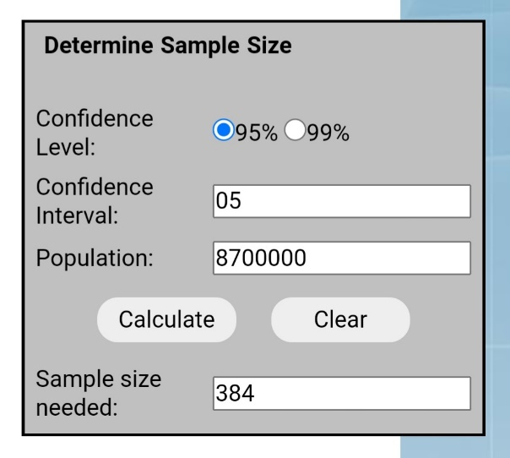

Therefore, Researcher planned to use 384 sample size for this study. Further, Western Province has a big number of retail fashion locations with varied retail fashion brands. Furthermore, the bulk of stores in Western Province are expanding their distribution activities with fashion brands (Ranaweera & Halwatura, 2014) And the majority social media users belongs to the western province of Sri Lanka (social-media-stats all sri-lanka, 2022). These arguments led to the decision to investigate this research study in the western province.

When it comes to other relevant studies, 207 samples have used to investigate effects on social media user generated content on purchase intention of automobiles in Sri Lanka ( Karunanayake & Madubashini, 2019). And, 300 samples used to examine the impact of social media marketing (UGC & FGC) on customer purchase intention among the fashion-wear customers in Sri Lanka (Sandunima, Kodagoda, Bandara, Viduranga, & Jayasuriya, 2019).

But, According to the limited time concerns, the Research data analysis have done by using **220** respondents as the sample.

# Sampling Technique

One of the most important factors that emphasizes the accuracy of research/survey results is sampling. Sampling is the process of selecting individuals or a subset of the population in order to derive statistical conclusions and estimate population characteristics. Probability sampling and nonprobability sampling are two types of sampling methodologies. Random individuals of a population are selected by setting a few selection criteria in probability (random) sampling. In that instance, each member has an equal chance to participate in various samples. Because of the nature of probability sampling, these procedures take longer and cost more than non-probability sampling. There is no equal chance of being chosen to sample in non-probability (non-random) sampling because it does not begin with a complete sampling frame. Non-probability sampling approaches, on the other hand, are less expensive and more practical, and are ideal for exploratory research and hypothesis generating (Fleetwood, 2020).

Therefore, As a result, to pick a sample from the population, this study use the convenience sampling approach, which is one of the non-probability sampling strategies ( Smith & Albaum, 2010).

Further, In the retail fashion business, Fleetwood (2020), employed convenience sampling to select a sample to investigate the impacts of social media user generated content on online purchasing. Because participants are frequently readily available, a convenience sample merely comprises those who happen to be the most accessible to the researcher. As a result, compared to other sampling procedures, convenience sampling is a simple and inexpensive way to collect data. Furthermore, convenience sampling frequently aids in overcoming many of the study limitations (Taherdoost, 2018). Thus, the goal of this study is to see if social media user generated content has a significant impact on consumer online purchase intentions in the retail fashion business. As a result, the researcher chooses convenience sampling approach based on the large number of social media users & customers who buy retail fashion (clothing) brands. Obtaining information from each customer is not straightforward ( Smith & Albaum, 2010).

## Method of Data Collection

Within the section, represent all the data collection methods in relation to the research study and clearly explain the steps taken in carrying out each method. Questionnaires use as per the primary data collection technique, if briefly explained the steps taken in carrying out the method, in first stage it can found a filtering question to screening out the correct target audience for the study. Then some standard questionnaires regarding the research which is going to investigate. Further, a questionnaire was designed concerning on variables to be measured through analysing indicators on the operationalization table in chapter 3 (Conceptualization and Operationalization) further some questions are grabbing from standard questionnaires and some questions added as per the requirement of the study. Structured questionnaire distribute among the sample to collect identical data in the same order, analyse them and present them using a quantitative method. Furthermore, gathered data and relevant theories from books, journals and articles are referred which are the secondary data sources. Primary data was collected by distributing the link of the online questionnaire through WhatsApp, Instagram and Facebook.

### Primary Data

In this research, primary data is playing an important role because it provides more updated and relevant information for the present research problem at hand. The source of primary data in this research was mainly obtained via a questionnaire which has been created by using Google Forms. All the questions are developed according to the indicators which are in operationalization table.

It is used to test the hypotheses developed in chapter 3 (Conceptualization and operationalization). Therefore, questionnaires were distributed online to the target respondents: which are individuals, fashion shoppers, exposed to UGC on Social Media who are living in the western province covering the districts Colombo, Gampaha and Kaluthara. Although collection of primary data is costly and time consuming compared to secondary data, still it can provide latest, reliable and relevant opinions equal to the current context.

### Secondary Data

In here some important data was collected from different secondary data sources. Previous studies based on social media UGC, and online purchase intention in online environment and the fashion shopping, therefore previous studies provide the researcher a comprehensive understanding for the conceptualization of the research study. In addition to previous studies, researcher used journal articles, reports and other electronic sources which are related to the research topic. Besides secondary data sources help to construct the study more systematically. Therefore, secondary data sources helped the author get the insights of the sample, study context, construction of the questionnaire and scaling procedures of the study.

## Questionnaire development

Closed-ended questions were adopted in the questionnaire. It provides respondents specifically limited options and requires them to choose the best suitable response based on their own opinions. Apart from that, simple English was used in the questions to ensure respondents understand the question fully. The questionnaire will include 5 sections. The first section is for the filtered question in order to screening out who are using Facebook and/ or Instagram. Second section is related to general questions which is related to their fashion retail products purchasing and consumption behaviour. Section three based on measurements of social media user generated contents and section four based on online purchase intention. The last section will carry out the demographic details of the sample. All the questions are developed according to the indicators which are in operationalization table.

A Pilot test run through WhatsApp and Facebook, initially after the questionnaire was reviewed and changed, to check the response rate and the nature of responses. Hence, the Independent variables contain 11 questions, on the other hand, Dependent variable: Online purchase intention consists of 4 questions.

## Scaling

All the questions were developed as per the indicators of the operationalization table in chapter three. All questions in part two measured on a five-point Likert scale, which is ranging from 1 to 5 where 1=Strongly Disagree, 5= Strongly Agree. It graphically represent as follows,

|  |  |  |  |  |
| --- | --- | --- | --- | --- |
| Strongly  Disagree (1) | Disagree (2) | Neutral (3) | Agree (4) | Strongly  Agree (5) |
|  |  |  |  |  |

## Data analysis techniques

For Data analysis of this research, researcher will be used the SPSS 26 data analysis software.

### Descriptive statistics

Descriptive statistics are used to describe the basic features of the data set which is gathered from an experimental study, also it descriptive statistics provide simple summaries about the sample together with simple graphical analysis.it includes ( Smith & Albaum, 2010),

* Measures of Frequency: (Count, Percent, Frequency): Measures of frequency can be used when it need to find how often a response is given.
* Measures of Central Tendency (Mean, Median, and Mode): Measures of Central Tendency helps to find the average or most commonly indicated response
* Measures of Dispersion or Variation (Range, Variance, and Standard Deviation): Measures of Dispersion or Variation can be used when it wants to show how "spread out" the data are. It is helpful to know when the data are so spread out that it affects the mean.
* Measures of Position (Percentile Ranks, Quartile Ranks): Measures of Position describes how scores fall in relation to one another. Relies on standardized scores. Can use this when it needs to compare scores to a normalized score.

### Inferential Statistics

Inferential statistics are used to estimate, predict or generalize from sample to the population. Further, Inferential Statistics investigate questions, models and hypotheses. In a research study inferential statistical methods can be identified as follows ( Smith & Albaum, 2010),

* Linear Regression Analysis: Linear Regression Analysis developed to recognize the effect of numerous variables on the dependent variable.
* Analysis of Variance (ANOVA): Analysis of variance can be identified as a group of statistical models to test if there is a significant difference between means.
* Statistical Significance (T-Test): Statistical significance is used to compare the means of two groups and understand if they are different from each other.
* Correlation Analysis: Correlation analysis used to understand the extent to which two variables are dependent on each other. In other words, it helps to measure the strength of any relationship between variables.

## Chapter Summary

There is used mainly dependent and independent variables to develop hypothesis. mainly Social Media User Generated Contents and purchase intentions are the main variable in this study. Main 3 sub variable have identified in the proposal. Those are derived by sub variables. it’s possible to understand the relationship of selected dependant and independent variable. It is Social Media User generated content and purchase intention. In this, there is the conceptual framework which is well presented. Researcher identified main 15 indicators. Main variables are Social Media UGC and purchase intention. This indicator and main 2 variables elaborate well in this operationalization table. In methodology it is highlighted as this study employs positivism research philosophy with deductive research approach. Quantitative research design enables to explore the role of user generated content on online purchase intention of retail fashion industry. This study is used the convenience sampling techniques when selecting sample from the population and there are 384 respondents have planned to take as the sample and 220 have used for the study. Online survey is used to gather data from respondents as a quantitative data collection method. 15 statements are constructed for the questionnaire in order to test relationship between the 2 main concepts: User generated content, Online purchase intention. SPSS Software is used to analyse research data by testing reliability and validity of the research data, descriptive statistics and hypotheses of the study.

**CHAPTER 4**

# DATA PRESENTATION AND ANALYSIS

## Chapter Introduction

The purpose of this chapter to recognize the key findings and the information that has been collected as results survey questionnaire previous literature reviews and then use that information to solve the research questions realizing the research objectives. As discussed in the methodology chapter, data were collected from 220 respondents in order to investigate the impact of social media user generated content (UGC) on online purchase intention; with special reference to retail fashion industry, in Sri Lanka. Furthermore, chapter presents the details about the Missing values, Distribution of Demographic factors, Descriptive analysis of the independent and dependent variables, correlation analysis and multiple linear regression analysis in order to achieve the research objectives of the study by using the IBM SPSS 26 data analysis software.

## Data Preparation for Analysis

As mentioned in chapter three, data were collected from 220 of individuals. The collected data was scanned for accuracy and precision. As the initial step, data were transcribed into SPSS version 26. After that, outliers were identified. Using several plots, diagrams those outliers were identified from the data set. Finally, 220 responses were forwarded for the final analysis.

### Missing Values

Missing values are values that are completely absent from the data. In SPSS, “missing values” may refer to 2 things:

* System missing values are values that are completely absent from the data. They are shown as periods in data view.
* User missing values are values that are invisible while analyzing or editing data. The SPSS user specifies which values -if any- must be excluded.

The missing values defined as “999” in the data view. So, in this research it does not has any cleaning and missing values because the researcher provide questionnaire. The researcher has used the frequency Table to present the summary of missing values in Table 3 in the study.

Table 3: Missing values

|  |  |  |  |  |  |  |  |  |  |  |  |  |  |  |
| --- | --- | --- | --- | --- | --- | --- | --- | --- | --- | --- | --- | --- | --- | --- |
|  | | Do you use Facebook and/or Instagram? (If Yes please proceed) | What is the retail fashion store, do you prefer mostly in order to purchase fashion products online? | How Long you have been using fashion retail products from that brand? | Have you ever referred to Social Media User Generated Contents (UGC), before taking a purchase decision in fashion retail products? | Which of the following Social Media platform, do you frequently use to refer User Generated Contents (UGC)? | What is the content type, you mostly consider to refer information about fashion retail products? | Gender | Living Area | Age | Employment Status | Highest Level of education | Marital status | Income |
| N | Valid | 220 | 220 | 220 | 220 | 220 | 220 | 220 | 220 | 220 | 220 | 220 | 220 | 220 |
| Missing | 0 | 0 | 0 | 0 | 0 | 0 | 0 | 0 | 0 | 0 | 0 | 0 | 0 |

Source: Data Survey 2022

In this data analysis missing values are zero. All string values, including null or blank values, are considered to be valid unless explicitly define them as missing.

## Descriptive Data analysis

The present study has used descriptive techniques to analyze the basic information which was collected from respondents. It has used in order to identify the overview of the profiles of respondents in the study.

### 4.3.1. Frequency distribution analysis of respondents by their personal characteristics

* **Analysis of content refer platforms**

Table 4 : Analysis of content refer platforms

|  |  |  |  |  |  |
| --- | --- | --- | --- | --- | --- |
|  | | Frequency | Percent | Valid Percent | Cumulative Percent |
| Valid | Yes | 220 | 100.0 | 100.0 | 100.0 |

Source: Data Survey 2022

Figure 4 : - Analysis of content refer platforms

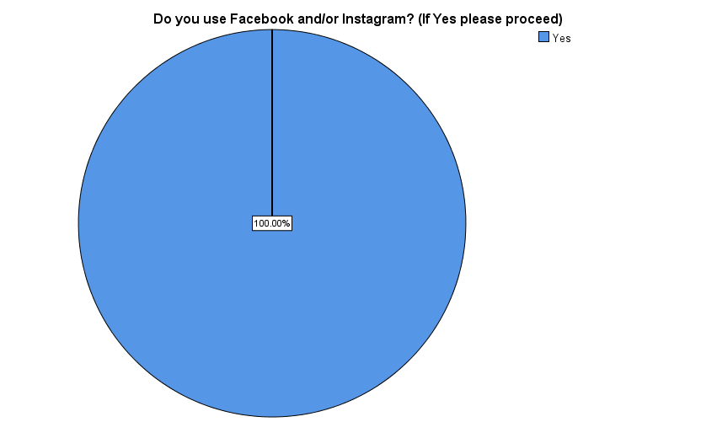

Source: Data Survey 2022

According to this data analysis, 100% of the selected sample are Facebook and/or Instagram users.

* **Analysis of mostly prefer retail fashion store**

Table 5 : Analysis of mostly prefer retail fashion store, to purchase fashion products online

|  |  |  |  |  |  |
| --- | --- | --- | --- | --- | --- |
|  | | Frequency | Percent | Valid Percent | Cumulative Percent |
| Valid | ODEL | 24 | 10.9 | 10.9 | 10.9 |
| GFlock | 14 | 6.4 | 6.4 | 17.3 |
| Chenara Dodge | 46 | 20.9 | 20.9 | 38.2 |
| Moose Clothing | 2 | .9 | .9 | 39.1 |
| Thilakawardhana | 83 | 37.7 | 37.7 | 76.8 |
| Nolimit | 16 | 7.3 | 7.3 | 84.1 |
| Fashion Bug | 35 | 15.9 | 15.9 | 100.0 |
| Total | 220 | 100.0 | 100.0 |  |

Source: Data Survey 2022

Figure 5 : Analysis of mostly prefer retail fashion store, to purchase fashion products online

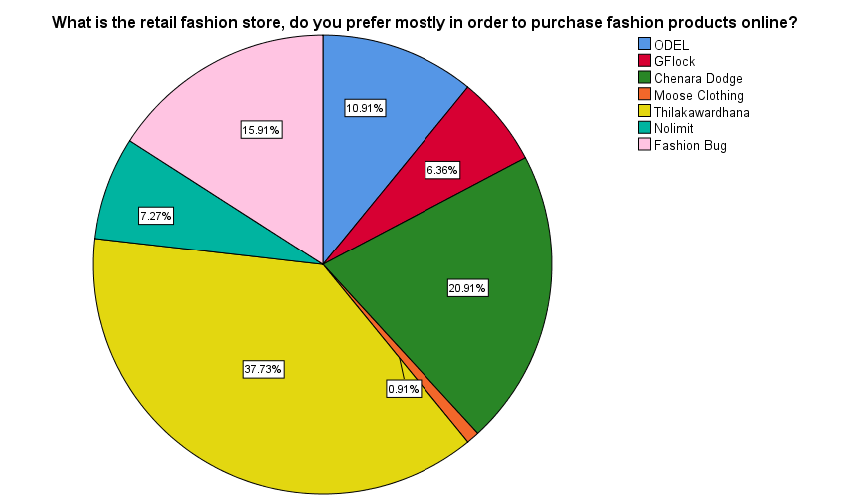

Source: Data Survey 2022

According to the above table, majority of the selected sample (37.7%) prefer to buy fashion products online from Thilakawardhana Company. As the second maximum value Chenara Dodge has a 20.91% as a upcoming brand. And also, minority of the selected sample (0.9%) prefer to buy fashion products online from Moose Clothing Company.

* **Analysis of retained time period with the mentioned brand**

Table 6 : Analysis of retained time period with the mentioned brand

|  |  |  |  |  |  |
| --- | --- | --- | --- | --- | --- |
|  | | Frequency | Percent | Valid Percent | Cumulative Percent |
| Valid | Less than one month | 11 | 5.0 | 5.0 | 5.0 |
| 1-6 months | 39 | 17.7 | 17.7 | 22.7 |
| 6-12 months | 43 | 19.5 | 19.5 | 42.3 |
| 1-3 years | 35 | 15.9 | 15.9 | 58.2 |
| More than 3 years | 92 | 41.8 | 41.8 | 100.0 |

Source: Data Survey 2022

Figure 6 : Analysis of retained time period with the mentioned brand

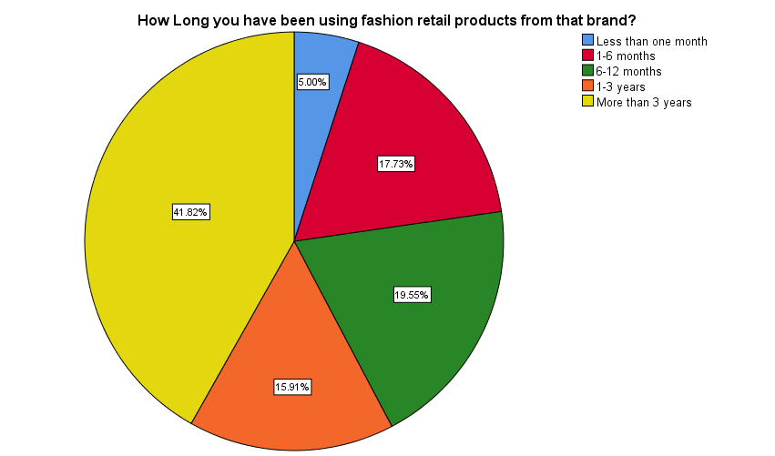

Source: Data Survey 2022

According to the above table, the majority of the selected sample (41.8%) have been using fashion retail products from the respective brand for more than 3 years. As the second maximum value it is 6-12 months with the brand. Most of them are Chenara Dodge preferred respondents. And also, the minority of the selected sample (5%) have been using fashion retail products from the respective brand for Less than one month.

* **Experiences regarding refer to Social Media User Generated Contents (UGC), before taking a purchase decision in fashion retail products**

Table 7: Experiences regarding refer to Social Media User Generated Contents (UGC), before taking a purchase decision in fashion retail products

|  |  |  |  |  |  |
| --- | --- | --- | --- | --- | --- |
|  | | Frequency | Percent | Valid Percent | Cumulative Percent |
| Valid | Yes | 220 | 100.0 | 100.0 | 100.0 |

Source: Data Survey 2022

Figure 7 : Experiences regarding refer to Social Media User Generated Contents (UGC), before taking a purchase decision in fashion retail products

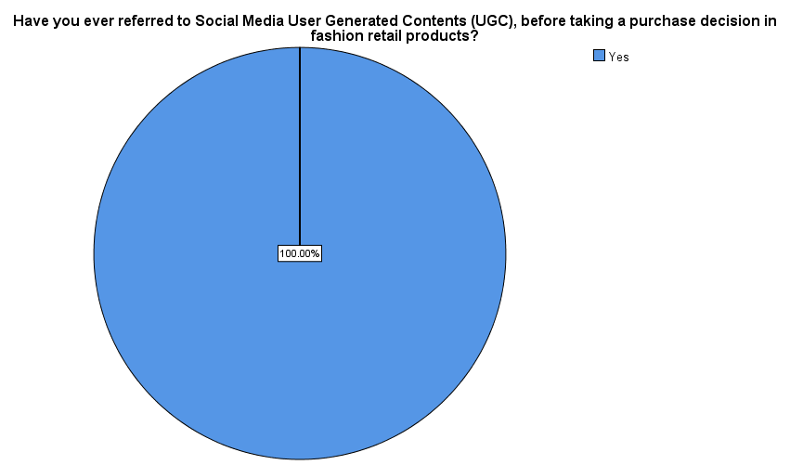

Source: Data Survey 2022

Significantly, according to this data analysis, 100% of the selected sample had ever referred to social media User Generated Content (UGC) before making a purchase decision on fashion retail products.

* **Analysis of frequently content refer platforms?**

Table 8: Analysis of frequently content refer platforms

|  |  |  |  |  |  |
| --- | --- | --- | --- | --- | --- |
|  | | Frequency | Percent | Valid Percent | Cumulative Percent |
| Valid | Facebook | 136 | 61.8 | 61.8 | 61.8 |
| Instagram | 31 | 14.1 | 14.1 | 75.9 |
| Both | 53 | 24.1 | 24.1 | 100.0 |
| Total | 220 | 100.0 | 100.0 |  |

Source: Data Survey 2022

Figure 8 : Analysis of frequently content refer platforms

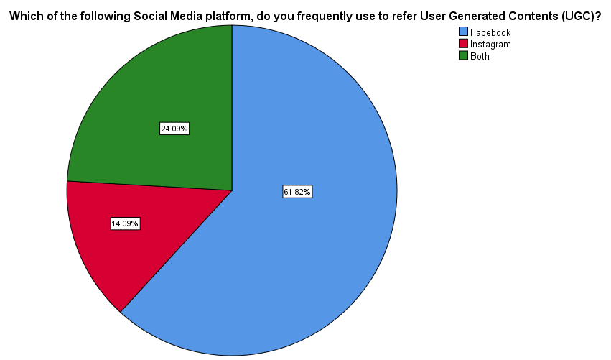

Source: Data Survey 2022

According to this data analysis, the majority (61.8%) of the selected sample frequently use the Facebook social media platform to refer to User Generated Content (UGC). And also, the minority (14.1%) of the selected sample frequently use the Instagram social media platform to refer to User Generated Content (UGC). Both platforms used 24% which is second majority.

* **Analysis about mostly considering content type**

Table 9: Analysis about mostly considering content type

|  |  |  |  |  |  |
| --- | --- | --- | --- | --- | --- |
|  | | Frequency | Percent | Valid Percent | Cumulative Percent |
| Valid | Images | 50 | 22.7 | 22.7 | 22.7 |
| Online reviews | 68 | 30.9 | 30.9 | 53.6 |
| Videos | 15 | 6.8 | 6.8 | 60.5 |
| Textual posts | 4 | 1.8 | 1.8 | 62.3 |
| Comments | 83 | 37.7 | 37.7 | 100.0 |
| Total | 220 | 100.0 | 100.0 |  |

Source: Data Survey 2022

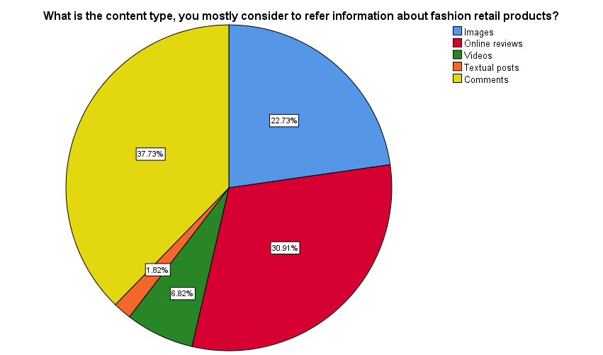Figure 9 : Analysis about mostly considering content type

Source: Data Survey 2022

According to this data analysis, what is the majority (37.7%) of the selected sample, the most considered type of content to refer information about fashion retail products is Comments. As the second majority online reviews (30.91%) can be identified and Images are positioned in third majority as (22.73%). And minority (1.8%) of the selected sample, the most considered type of content to refer information about fashion retail products is Textual posts.

* **Gender Composition**

Table 10: Gender composition

|  |  |  |  |  |  |
| --- | --- | --- | --- | --- | --- |
|  | | Frequency | Percent | Valid Percent | Cumulative Percent |
| Valid | Male | 94 | 42.7 | 42.7 | 42.7 |
| Female | 126 | 57.3 | 57.3 | 100.0 |
| Total | 220 | 100.0 | 100.0 |  |

Source: Data Survey 2022

Figure 10 : Gender composition

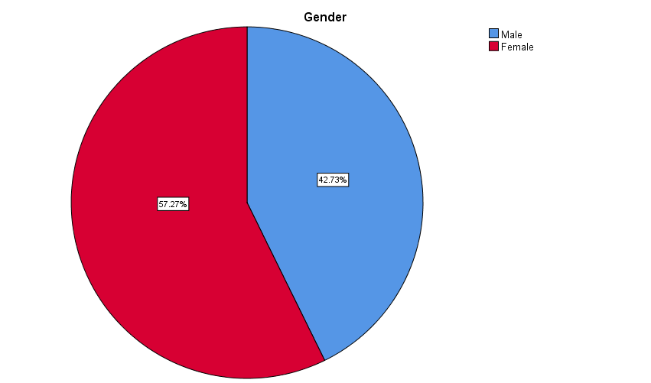

Source: Data Survey 2022

As observed from figure 10, it is clear that the majority of the represents, 57.3% were female as opposed to males who were 42.7%. This presupposes that generally, the margin between females and males is high.

* **Living Area Analysis**

Table 11: Area analysis

|  |  |  |  |  |  |
| --- | --- | --- | --- | --- | --- |
|  | | Frequency | Percent | Valid Percent | Cumulative Percent |
| Valid | Colombo | 109 | 49.5 | 49.5 | 49.5 |
| Gampaha | 85 | 38.6 | 38.6 | 88.2 |
| Kalutara | 26 | 11.8 | 11.8 | 100.0 |
| Total | 220 | 100.0 | 100.0 |  |

Source: Data Survey 2022

**Figure 11 :Area Analysis**

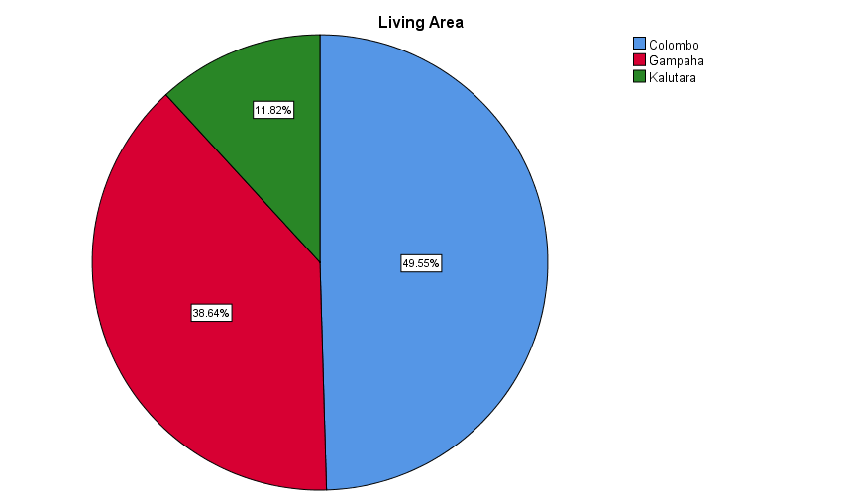

Source: Data Survey 2022

**49.2%**

As observed from figure 11, it is clear that the majority of the represents, 49.5% were from Colombo district. The minority of the represents, 11.8% were Kaluthara district and others represents Gampaha District as the second majority which is 38.64%..

* **Age Analysis**

Table 12 : Age analysis

|  |  |  |  |  |  |
| --- | --- | --- | --- | --- | --- |
|  | | Frequency | Percent | Valid Percent | Cumulative Percent |
| Valid | 18-28 years | 147 | 66.8 | 66.8 | 66.8 |
| 28-38 years | 44 | 20.0 | 20.0 | 86.8 |
| 38-48 years | 21 | 9.5 | 9.5 | 96.4 |
| 48-58 years | 6 | 2.7 | 2.7 | 99.1 |
| 58+ years | 2 | .9 | .9 | 100.0 |
| Total | 220 | 100.0 | 100.0 |  |

Source: Data Survey 2022

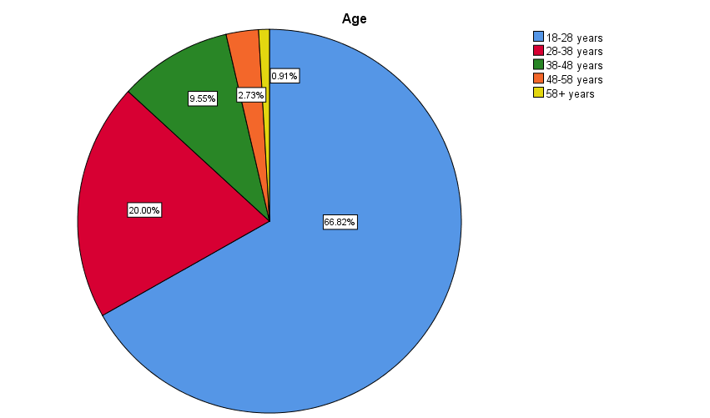Figure 12 : Age Analysis

Source: Data Survey 2022

According to figure 12, the highest percentage of the respondents were from the group of 18-28 years and it was 66.8% of the total sample. As second Majority there are 20.00% respondents are in to 28-38 category. In 38-48 Age category they are in to third majority which is 9.55%. And also, the lowest percentage of the respondents were from the group of above 58 years and it was 0.9% of the total sample.

* **Employment Analysis**

Table 13 : Employment Analysis

|  |  |  |  |  |  |
| --- | --- | --- | --- | --- | --- |
|  | | Frequency | Percent | Valid Percent | Cumulative Percent |
| Valid | Student-Employed | 81 | 36.8 | 36.8 | 36.8 |
| Full time student | 22 | 10.0 | 10.0 | 46.8 |
| Employed | 84 | 38.2 | 38.2 | 85.0 |
| Unemployed | 14 | 6.4 | 6.4 | 91.4 |
| Self-employed/Entrepreneur | 17 | 7.7 | 7.7 | 99.1 |
| Retired | 2 | .9 | .9 | 100.0 |
| Total | 220 | 100.0 | 100.0 |  |

Source: Data Survey 2022

Figure 13 : Employment Analysis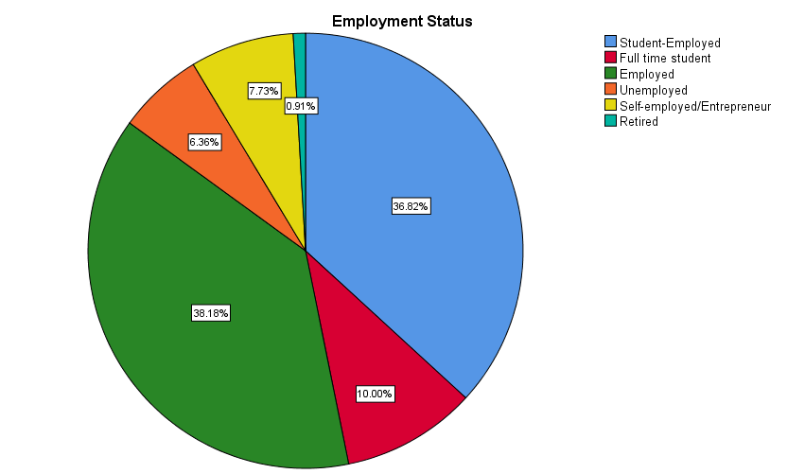

Source: Data Survey 2022

According to the table, majority of respondents employment Status the Employed as percentage of 38.2%. As the second majority it is student-employed (36.82%) those who are undergraduates when it analysed deeply. Full time students take the third majority which is 10%. And also, minority of respondents employment Status the Retired as percentage of 0.9%.

* **Highest Educational Level Analysis**

Table 14: Education Level Analysis

|  |  |  |  |  |  |
| --- | --- | --- | --- | --- | --- |
|  | | Frequency | Percent | Valid Percent | Cumulative Percent |
| Valid | A/L | 4 | 1.8 | 1.8 | 1.8 |
| Diploma/Professional qualification | 47 | 21.4 | 21.4 | 23.2 |
| Undergraduate | 99 | 45.0 | 45.0 | 68.2 |
| Graduate | 51 | 23.2 | 23.2 | 91.4 |
| Masters | 19 | 8.6 | 8.6 | 100.0 |
| Total | 220 | 100.0 | 100.0 |  |

Source: Data Survey 2022

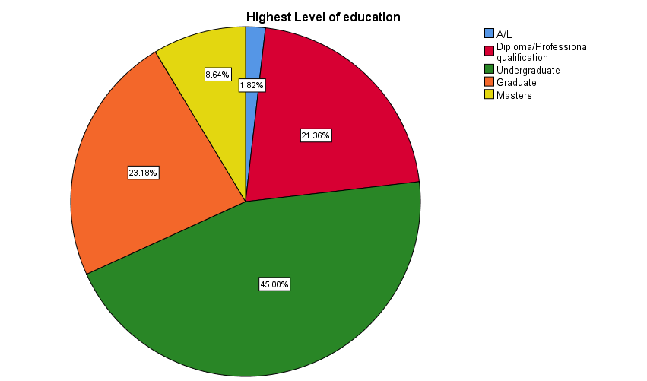Figure 14 : Education Level Analysis

Source: Data Survey 2022

According to the figure 14, the highest percentage of the respondents were from the hold Undergraduate and it was 45% of the total sample. When it comes to second highest value which 23.18% by Graduates and third majority is from Diploma and professional qualification having respondents that percentage is 21.36%. And also, the lowest percentage of the respondents were from A/L and it was 1.8% of the total sample.

* **Marital Status Analysis**

Table 15: Marital Status Analysis

|  |  |  |  |  |  |
| --- | --- | --- | --- | --- | --- |
|  | | Frequency | Percent | Valid Percent | Cumulative Percent |
| Valid | Unmarried | 162 | 73.6 | 73.6 | 73.6 |
| Married | 58 | 26.4 | 26.4 | 100.0 |
| Total | 220 | 100.0 | 100.0 |  |

Source: Data Survey 2022

Figure 15 : Marital Status Analysis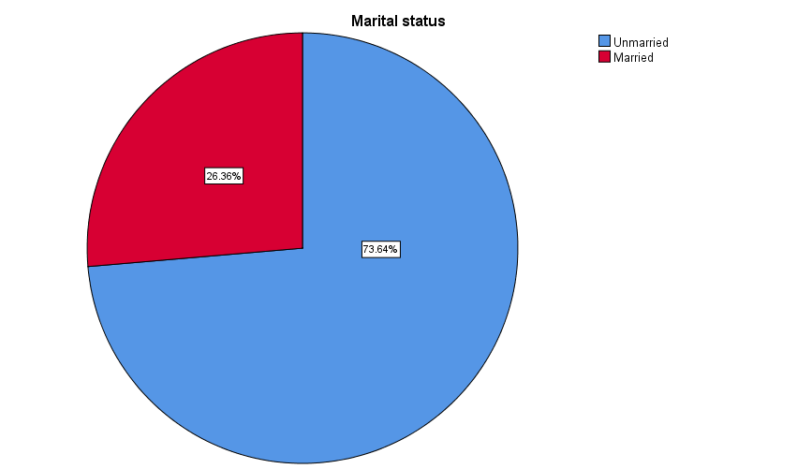

Source: Data Survey 2022

**29.2%**

**70.8%**

As observed from figure 15, it is clear that the majority of the represents, 73.6% were unmarried as opposed to married who were 26.4%.

* **Income Level Analysis**

Table 16: Income Level Analysis

|  |  |  |  |  |  |
| --- | --- | --- | --- | --- | --- |
|  | | Frequency | Percent | Valid Percent | Cumulative Percent |
| Valid | Less than 25000 LKR | 67 | 30.5 | 30.5 | 30.5 |
| 25000 - 50000 LKR | 79 | 35.9 | 35.9 | 66.4 |
| 50000 - 75000 LKR | 33 | 15.0 | 15.0 | 81.4 |
| 75000 - 100000 LKR | 28 | 12.7 | 12.7 | 94.1 |
| 100000 and above | 13 | 5.9 | 5.9 | 100.0 |
| Total | 220 | 100.0 | 100.0 |  |

Source: Data Survey 2022

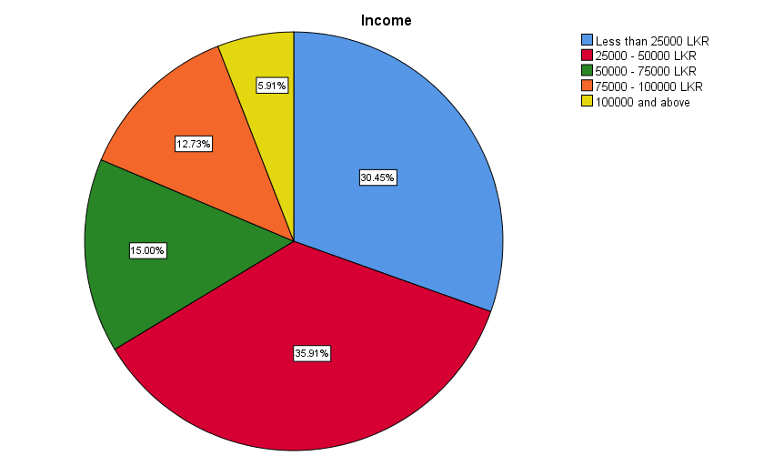Figure 16 : Income Level Analysis

Source: Data Survey 2022

According to table, majority of the respondents who have income 25000 - 50000 LKR is 35.9%. When it deeply analysed, there are 30.45% respondents who have less than 25000 LKR income which takes the second majority. 50000-75000 LKR monthly income have been collocated for 15% as the third majority. And also, minority of the respondents who have income LKR 100000 and above is 5.9%.

### Descriptive distribution analysis for variables

According to the Descriptive statistics of the variables which examine through the Likert scale questionnaire are expected to achieve mean value close to 5. As well whether data is more spread out from the mean represents by the standard deviation.

Table 17: Descriptive Statistics

|  |  |  |  |  |  |  |  |  |
| --- | --- | --- | --- | --- | --- | --- | --- | --- |
|  | N | | Mean | Median | Std. Deviation | Variance | Minimum | Maximum |
| Valid | Missing |
| PC1 | 220 | 0 | 3.92 | 4.00 | .916 | .839 | 1 | 5 |
| PC2 | 220 | 0 | 4.06 | 4.00 | .963 | .927 | 1 | 5 |
| PC3 | 220 | 0 | 4.14 | 4.00 | 1.020 | 1.041 | 1 | 5 |
| PC4 | 220 | 0 | 3.95 | 4.00 | 1.041 | 1.084 | 1 | 5 |
| PC5 | 220 | 0 | 3.94 | 4.00 | .996 | .991 | 1 | 5 |
| PU1 | 220 | 0 | 4.08 | 4.00 | .947 | .897 | 1 | 5 |
| PU2 | 220 | 0 | 4.13 | 4.00 | 1.021 | 1.043 | 1 | 5 |
| PU3 | 220 | 0 | 4.15 | 4.00 | .970 | .941 | 1 | 5 |
| PR1 | 220 | 0 | 4.26 | 4.00 | .917 | .841 | 1 | 5 |
| PR2 | 220 | 0 | 4.20 | 4.00 | .894 | .800 | 1 | 5 |
| PR3 | 220 | 0 | 4.05 | 4.00 | .905 | .819 | 1 | 5 |
| OPI1 | 220 | 0 | 4.23 | 4.00 | .929 | .864 | 1 | 5 |
| OPI2 | 220 | 0 | 4.23 | 4.00 | .903 | .816 | 1 | 5 |
| OPI3 | 220 | 0 | 4.22 | 4.00 | .964 | .929 | 1 | 5 |
| OPI4 | 220 | 0 | 4.28 | 5.00 | .917 | .841 | 1 | 5 |

Source: Data Survey 2022

Mean values have measured as per the following decision criteria.

* 0.1 ≤ X < 2.5 Not at all agree
* 2.5 ≤ X < 3.5 Moderately agree
* 3.5 ≤ X < 5 Almost agree

According to 17 table, Descriptive statistical results which indicate in the table shows that the mean values of all factors are social media user generated content (UGC) on online purchase intention above. According to the data analysis of this study, the all mean values are greater than 3.5. So that, respondents have almost agreed with the variables. Standard deviation emphasizes that how data are scattered around the mean and how far one value range away from the mean. When considering the standard deviation of the variables, PR2 shows the lowest value. It says that most of the numbers which have given by respondents are close to the average which has calculated. Since PC4 shows the highest standard deviation value, is can says that the numbers are somewhat spread than the variables.

## Validity Test

* **KMO (Measure of Sample Adequacy)**

In table 4.16, the calculated Kaiser-Meyer-Olkin (KMO) measure of sample adequacy is 0.835 for the online purchase intention. For High values (close to 1.0) generally indicate that a factor analysis may be useful with your data. If the value is less than 0.50, the results of the factor analysis probably won't be very useful. Based on the KMO test it is inferred that the adequacy of the sample enables to run factor analysis and further it indicates the suitability of the research data for structure detection.

|  |  |  |
| --- | --- | --- |
| **KMO and Bartlett's Test** | | |
| Kaiser-Meyer-Olkin Measure of Sampling Adequacy. | | .835 |
| Bartlett's Test of Sphericity | Approx. Chi-Square | 506.996 |
| df | 6 |
| Sig. | .000 |

Table 18: KMO and Bartlett's Test

Source: Data Survey 2022

**Bartlett's Test of Sphericity**

From the above table 18, the Approximate Chi-Square value is 506.996 for social media user generated content (UGC) on online purchase intention respectively. The significance values for all factors are (0.000) which are less than the level of significance 0.05, so this test reveal the correlations among the variables considered for the study and a factor analysis considered for data reduction is efficient and justifiable.

### (Reliability) Conbranches’ Alpha

As mentioned in chapter three, data were collected from 220 of individuals. The collected data was scanned for accuracy and precision. As the initial step, data were transcribed into SPSS version 26. After that, outliers were identified. Using several plots, diagrams those outliers were identified and removed from the data set. Finally, 220 responses were forwarded for the final analysis.

Table 19 : Cronbach’s Alpha table

|  |  |  |
| --- | --- | --- |
| **Constructs** | **Number of Items** | **Cronbach's Alpha** |
| Perceived Credibility | 5 | 0.854 |
| Perceived Usefulness | 3 | 0.721 |
| Perceived Risk | 3 | 0.719 |
| Online Purchase Intention | 4 | 0.834 |
| Overall Reliability | 15 | 0.924 |

Source: Data Survey 2022

Cronbach’s Alpha analysis is performed for the study to measure the consistency of the results over time by respondents. Cronbach’s Alpha Value need to meet the standard of 0.7 to consider as reliable instruments. Therefor table shows the reliability acceptance of the instruments of the questionnaire in this study. In order to those values, internal consistency among the indicators which have used by the researcher in the questionnaire at a good level.

For this instrument (tool), Cronbach’s Alpha was 0.9244 with a significance of P < 0.0005. So the internal consistency was excellent and the research tool was reliable, and will give credible results.

## Multivariate Assumptions

### Normality

Normality means whether the distribution of the test is normally distributed with zero (0) mean with a standard deviation of one (1) and a symmetric bell-shaped curve. It is used to determine if the sample data is derived from a naturally distributed group (within a certain tolerance). There are several measures and tests which can be applied to test the assumption of Normality like skewness and Kurtosis test, Kolmogorov-Smirnov test, Shapiro-Wilk’s test and etc. Among those tests here the researcher has used the skewness and kurtosis test.

#### Skewness and kurtosis

The skewness of a distribution is the degree to which the curve appears to be twisted to the left or right. Simply put, skewness measures the deviation of a distribution from a normal distribution. If the skewness of the model's components remains within the range of -2 to +2, this indicates a better level of accuracy. A symmetrical dataset will have skewness equal to 0 if it is symmetrical. Thus, the skewness of a normal distribution will be zero. Skewness gauges the proportional size of the two tails.

In relation to a normal distribution, kurtosis indicates whether the data are skewed or flat (George & Mallery, 2018), The value is frequently compared to the kurtosis of the normal distribution, which is equal to 3, and if the kurtosis findings are between -3 and +3, the data are regularly distributed. It quantifies the likelihood in the tails and the sum of the tails' sizes.

Table 20 : Skewness and Kurtosis

|  |  |  |  |  |
| --- | --- | --- | --- | --- |
|  | Skewness | Std. Error of Skewness | Kurtosis | Std. Error of Kurtosis |
|
| PC1 | -.998 | .164 | 1.328 | .327 |
| PC2 | -1.212 | .164 | 1.448 | .327 |
| PC3 | -1.397 | .164 | 1.682 | .327 |
| PC4 | -1.116 | .164 | .915 | .327 |
| PC5 | -1.216 | .164 | 1.440 | .327 |
| PU1 | -1.075 | .164 | .962 | .327 |
| PU2 | -1.296 | .164 | 1.420 | .327 |
| PU3 | -1.305 | .164 | 1.614 | .327 |
| PR1 | -1.362 | .164 | 1.814 | .327 |
| PR2 | -1.023 | .164 | .689 | .327 |
| PR3 | -1.302 | .164 | 2.210 | .327 |
| OPI1 | -1.408 | .164 | 1.907 | .327 |
| OPI2 | -1.366 | .164 | 2.013 | .327 |
| OPI3 | -1.468 | .164 | 2.221 | .327 |
| OPI4 | -1.440 | .164 | 2.045 | .327 |

Source: Data Survey 2022

The results in table 20 shows that all the skewness statistics are between the acceptable ranges of skewness and kurtosis. Therefore, it shows that the data distribution is normal.

Figure 17 : p-p plot of regression standardized residual

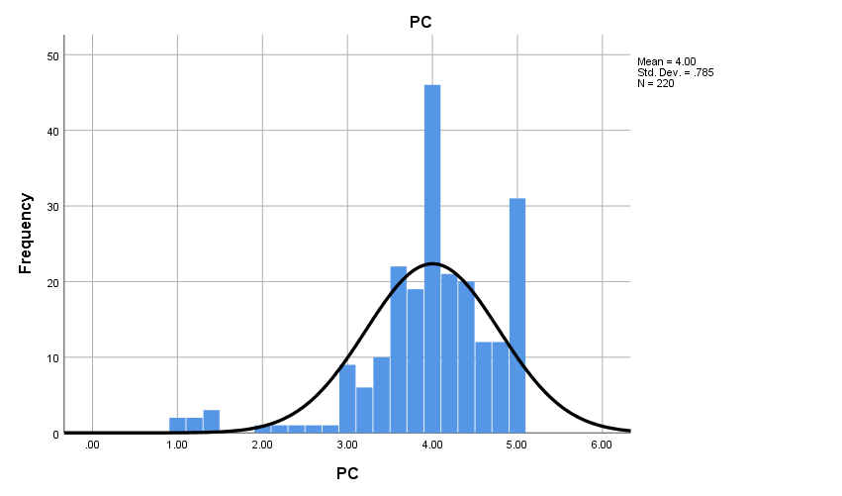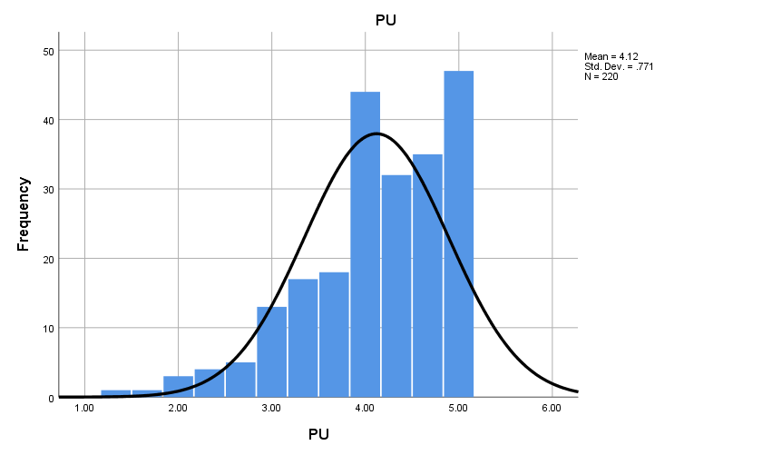

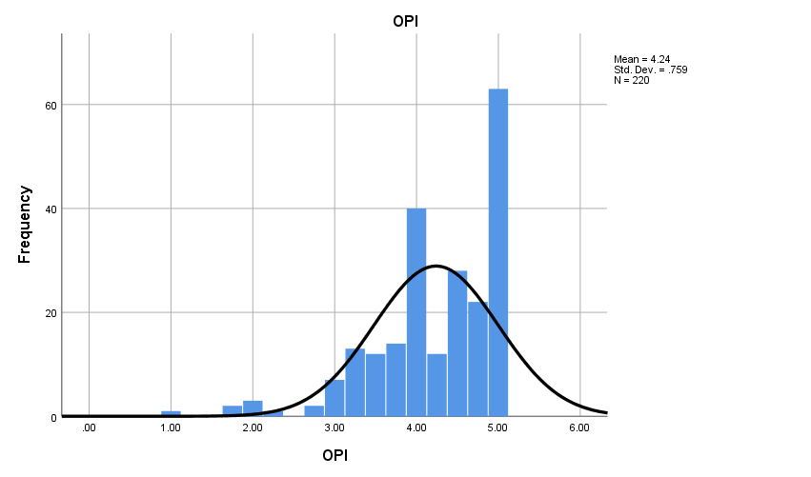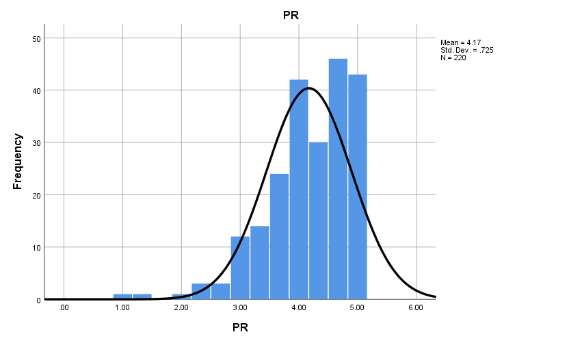

Source: Data Survey 2022

## Correlation Coefficient Analysis

The aim of this technique is to analyze the objectives of this study, evaluate the impact of social media user generated content (UGC) on online purchase intention; with special reference to retail fashion industry, in Sri Lanka.

Table 21: Correlation table

|  |  |  |  |  |  |
| --- | --- | --- | --- | --- | --- |
|  | | PC | PU | PR | OPI |
| PC | Pearson Correlation | 1 | .657** | .598** | .656** |
| Sig. (2-tailed) |  | .000 | .000 | .000 |
| N | 220 | 220 | 220 | 220 |
| PU | Pearson Correlation | .657** | 1 | .694** | .712** |
| Sig. (2-tailed) | .000 |  | .000 | .000 |
| N | 220 | 220 | 220 | 220 |
| PR | Pearson Correlation | .598** | .694** | 1 | .736** |
| Sig. (2-tailed) | .000 | .000 |  | .000 |
| N | 220 | 220 | 220 | 220 |
| OPI | Pearson Correlation | .656** | .712** | .736** | 1 |
| Sig. (2-tailed) | .000 | .000 | .000 |  |
| N | 220 | 220 | 220 | 220 |
| **. Correlation is significant at the 0.01 level (2-tailed). | | | | | |

Source: Data Survey 2022

A correlation analysis was used to gauge how strongly the independent and dependent variables were related. Table 21, displays the correlations between the variables. According to Table 21's findings, there are statistically significant relationships between Perceived Credibility, Perceived Usefulness, and Perceived Risk as well as the online purchase intention The fact that none of the correlation coefficients of the relevant inter-construct correlations were above 0.85 indicates that the model is free of multicollinearity issues. Additionally, Table 21 shows that the squared root AVE value for each variable was greater than the corresponding inter-construct correlations, supporting the validity of each variable's discriminant function in the study.

The aim of this technique is to analyze the objectives of this study, evaluate the impact of social media user generated content (UGC) on online purchase intention; with special reference to retail fashion industry, in Sri Lanka.

## Multi Co-linearity Test

VIF value can be used to test the multi-collinearity of the independent variables of the regression model. It is required to have this VIF value greater than 0.2. Table shows all the VIF values of the regression models in the present study are greater than 0.2. Therefore, the model is free from multi-collinearity problems and it is highly valid.

Table 22: VIF and Tolerance values of multiple linear regression mode

|  |  |  |  |
| --- | --- | --- | --- |
| **Coefficientsa** | | | |
| Model | | Collinearity Statistics | |
| Tolerance | VIF |
| 1 | PC | .530 | 1.888 |
| PU | .427 | 2.344 |
| PR | .483 | 2.072 |
| a. Dependent Variable: OPI | | | |

Source: Data Survey 2022

## Multiple Regression Analysis

Multiple linear regression (MLR) analysis was applied to investigate the impact of social media user generated content (UGC) on online purchase intention; with special reference to retail fashion industry, in Sri Lanka. coefficient of determination-r2 is the measure of proportion of the variance of dependent variable about its mean that is explained by the independent or predictor variables ( Smith & Albaum, 2010). Higher value of R2 represents greater explanatory power of the regression equation.

Table 23 : Multiple linear regression

|  |  |  |  |  |  |  |
| --- | --- | --- | --- | --- | --- | --- |
| **Coefficientsa** | | | | | | |
| Model | | Unstandardized Coefficients | | Standardized Coefficients | t | Sig. |
| B | Std. Error | Beta |
| 1 | (Constant) | .446 | .193 |  | 2.315 | .022 |
| PC | .222 | .054 | .229 | 4.138 | .000 |
| PU | .276 | .061 | .281 | 4.540 | .000 |
| PR | .423 | .061 | .404 | 6.960 | .000 |
| a. Dependent Variable: OPI | | | | | | |

Source: Data Survey 2022

Unstandardized coefficients indicated how much the dependent variable varies with an independent variable, when all other independent variables are held constant. The beta coefficients indicated that further the analysis also considered the impact of social media user generated contents on online purchase intention. The following regression equation was obtained,

***OPI = β0 +*** ***β1 PC + β2 PU +*** ***β3 PR + ε***

***IM = 0.446 + 0.229W + 0.281M + 0.404F + ε***

Where,

* **OPI** = Online Purchase Intention
* **β0, β1** = Slopes of the curve
* **Ɛ** = Standard Error
* **PC =** Perceived Credibility
* **PU =** Perceived Usefulness
* **PR =** Perceived Risk

When the value of Online Purchase Intention is equal to the zero levels, the value of the Online Purchase Intention will be equal to this constant value. According to the above model, the Online Purchase Intention will equal to 0.446 due to average change of the from one unit.

By using Coefficient table, can be tested the significance value of each independent variable that the researcher was considering. P value was used to test it and if the P value less than or equal 0.05, the variables are significant.

Table 24: Model Summary

|  |  |  |  |  |
| --- | --- | --- | --- | --- |
| **Model Summary** | | | | |
| Model | R | R Square | Adjusted R Square | Std. Error of the Estimate |
| 1 | .805a | .648 | .643 | .45324 |
| a. Predictors: (Constant), PR, PC, PU | | | | |

Source: Data Survey 2022

Table 25: ANOVA

|  |  |  |  |  |  |  |
| --- | --- | --- | --- | --- | --- | --- |
| **ANOVAa** | | | | | | |
| Model | | Sum of Squares | df | Mean Square | F | Sig. |
| 1 | Regression | 81.724 | 3 | 27.241 | 132.608 | .000b |
| Residual | 44.372 | 216 | .205 |  |  |
| Total | 126.097 | 219 |  |  |  |
| a. Dependent Variable: OPI | | | | | | |
| b. Predictors: (Constant), PR, PC, PU | | | | | | |

Source: Data Survey 2022

The regression coefficient, which may be represented by any value between 0 and 1, was replaced by R square. To determine how much each independent influences the dependent, this was done. The model summary of regression analysis is shown in Table 24. The explanatory power (R2) value indicates how much the independent factors contribute to the variance of the dependent variable. As a result, the R2 value for this table is 0.648 (64.8%). Therefore, Perceived Credibility, Perceived Usefulness, and Perceived Risk all contributed to the 64.8% of consumers who intended to continue online purchasing.

The P values for Perceived Credibility, Perceived Usefulness, and Perceived Risk were all less than 0.05. Therefore, these elements play a key role in determining whether online purchase intention; with special reference to retail fashion industry, in Sri Lanka.. Perceived Risk was the greatest beta value, respectively (beta =0.404). Perceived Credibility was the least beta value, respectively (beta =0.229).

Analysis of variance is presented in the following table and includes the sum of the square, degree of freedom, F value and P-value and is presented to ensure the overall significance of the model.

According to table 25, the significance value of the impact of social media user generated content (UGC) on online purchase intention is 0.000. Further F-value of the model is also a higher value. Therefore, the researcher concluded that there is an impact of social media user generated content (UGC) on online purchase intention with a 95% level of confidence. The P-value (0.000) < 0.05.

In order to these results, the overall model can be used statistically and it shows that there is a positive impact of social media user generated content (UGC) on online purchase intention.

## Hypothesis Testing Result

Table 26: Result of Testing the Hypothesis

|  |  |  |  |  |  |
| --- | --- | --- | --- | --- | --- |
| **Path** | **Hypotheses** | **P Value**  **(Significance Level )** | **Beta Value** | **Relationship** | **Decision** |
| Perceived Credibility and Online purchase intention | H1: Perceived Credibility has a positive significant impact on online purchase intention. | 0.000 | 0.229 | Positive significant impact | Accepted |
| Perceived usefulness and Online purchase intention | H2: Perceived usefulness has a positive significant impact on online purchase intention. | 0.000 | 0.281 | Positive significant impact | Accepted |
| Perceived risk and Online purchase intention | H3: Perceived risk has a positive significant impact on online purchase intention. | 0.000 | 0.404 | Positive significant impact | Accepted |

Source: Author Developed

In detail explanation result of each alternative hypothesis testing as follows,

**H1: Perceived credibility has a significant positive impact on online purchase intention**

The alternative hypothesis can therefore be accepted, while the null hypothesis can be rejected. Because, online purchase intention is changed by 22.9% when the independent variable varies, indicating that Perceived Credibility have a positive and statistically significant effect on online purchase intention.

**H2: Perceived usefulness has a significant positive impact on online purchase intention**

The alternative hypothesis can therefore be accepted, while the null hypothesis can be rejected. Because, online purchase intention is changed by 28.1% when the independent variable varies, indicating that Perceived Usefulness have a positive and statistically significant effect on online purchase intention.

**H3: Perceived risk has a significant positive impact on online purchase intention**

The alternative hypothesis can therefore be accepted, while the null hypothesis can be rejected. Because, online purchase intention is changed by 40.4% when the independent variable varies, indicating that Perceived Risk have a positive and statistically significant effect on online purchase intention.

## Chapter Summery

SPSS 26 Version was used to analyze the collected data in this chapter. Gender, age, monthly income, employment, education, geographic information, and responses to social media, content, and online purchasing were all described first. It next tests the data's reliability, validity, as well as three hypothesis. Hypotheses were tested using multiple regression to show a relationship between independent variables (perceived usefulness, perceived credibility, and perceived risk) and the dependent variable of Online purchase intention. As a result of the findings, the following hypothesis are accepted and identified all independent variables having a positive significant impact on online purchase intention.

**CHAPTER 05**

# CONCLUSION AND RECOMMENDATIONS

## Introduction

The main purpose of this research was to investigate into the impact of social media user-generated content on online purchase intention in the Sri Lankan retail fashion industry. In this chapter the whole study has concluded by stating the most significant insights and findings based on statistical data driven suggestions for digital marketers and for the businessman. The study was focused on the perceived credibility, perceived usefulness and perceived risk variables of social media user generated content and online purchase intention. This chapter summarizes the research findings, disclosures, and findings related to the research investigation. The outcomes of the research are discussed in the body of this chapter, and some recommendations for practitioners are made. This chapter also allows for the discussion of the research's contribution to theory and practice. Finally, the chapter makes recommendations for future research.

## Summary of Research Study

The impact of social media user-generated content on retail fashion customers' online purchase intention was the focus of this research. To collect data through an online questionnaire, 220 people from Western Province were chosen as the sample for the final analysis. To evaluate research objectives, SPSS 26 data analysis software was used to do demographic analysis, descriptive analysis, correlation, and regression analysis.

## Research Problem Statement Achievement

The main research problem of this study is “How does social media user generated content influence on online purchases intention; with special reference to retail fashion customers”. It was tested with hypotheses which show the Perceived credibility, Perceived usefulness and Perceived risk all were having positive and significant impact on online purchase intention with significant level of 0.000. It means P value is 0.000 for all 3. In overall, It indicates that Social Media User generated content has a significant impact on online purchase intention.

## Discussions and Findings

Mainly this research study intended to investigate the impact of social media user generated contents on online purchase intention. The relationship between these variables are solely related to the retail fashion industry in Sri Lanka which is one of the most engaging and rising industry in Sri Lankan context. When it comes to this retail fashion industry in Sri Lanka, which has a massive completion and major players strive to keep their customers while attracting new customers to increase their market share in the particular industry. Therefore, social media user generated contents plays a major role (Ranaweera & Halwatura, Analysis of Tourism and Fashion Retailing; A Sri Lankan Perspective, 2014).

Moreover, the results of the previous section have been demonstrated that social media user generated content is directly influenced on online purchase intention of the retail fashion industry in Sri Lanka. Further, it influence for customers when it comes to the decision making process of the fashion retailors regarding the purchase intention of their customers and consumer behaviour. The impact of social media activities, content creations in raising customers purchase intensions ( Resnik & Koklič, 2018). Based on the previous studies and existing frameworks/models which is introduced by various authors, the researcher has developed a model with the reference to social media user generated contents on online purchase intention. Mainly investigating the social media user generated contents on online purchase intention with the relevant measurements, the researcher has indicated three independent variables ( Perceived credibility, perceived usefulness, perceived risk ) has the relationship between online purchase intention and that variables. Conceptual framework was developed by doing a technical contribution while social media ser generated contents has taken as the independent variable and online purchase intention has selected as the dependent variable for the study. A sample of 220 respondents were taken after running a filtering process. The sample size for this study was decided by the sample calculator. The required data to analyze was gathered via a structured questionnaire which was created via Google forms. Thus, the gathered data was analyzed by using SPSS 26 software.

Further, This study was subjected to the Western province because the most of the retail fashion brands are in to western province. It means, Western Province has a big number of retail fashion locations with varied retail fashion brands. Furthermore, the bulk of stores in Western Province are expanding their distribution activities with fashion brands (Ranaweera & Halwatura, 2014). And the majority of Facebook & Instagram like social media users belongs to the western province of Sri Lanka (social-media-stats all sri-lanka, 2022). According to the collected data, out of 220 respondents 49.5% of people were from Colombo district and 42.7% people were male while females were 57.3% from the respondents. When it comes to mostly preferred retail fashion brand in order to purchase fashion products online in Sri Lanka Thilakawardhana accounts to 33.2% while Chenara Dodge (20.9%) has taken place at the second place in the list based on the analysis. It have been explained in chapter 04. It is an overall indicator of the market share of retail fashion industry in Sri Lanka.

Further, sample is fairly qualifying. According to the collected data, in age distribution 18-28 people have responded as the majority which is 66.8%. When it deeply analysed, Considerable amount of 18-28 respondents are undergraduates. When it comes to the highest educational level of the proceeded sample, 45% of people were undergraduates while 23.2% of people were graduates and 21.4% of people are Diploma/ Professional qualification people. Moreover, it is shown that selected sample is knowledgeable and literate enough.. when it Considering the income distribution of the sample 35.9% were hold that25000 LKR - 50,000 LKR range of an income. Therefore, it is in a considerable level of disposable income. Thus, 30.5% of respondents have less than 25000 LKR of an income. According to the study 41.8% of people are being purchased their retail fashion products online more than three years. Hence majority of people from the sample have purchased online their retail fashion products at least more than 3 years. Further, 19.5% of people have been purchased their retail fashion products online in the range 6-12 months of a time period. When it deeply analysed, Considerable amount of Chenara Dodge fashion retail products purchasing respondents are in this 6-12 months category.

According to the conducted comprehensive data analysis, following results can be conducted through the research study. Data set ensured reliability by satisfying above 0.924 Cronbach alpha value and validity was proven through above 0.5 value of Kaiser-Meyer Olkin Measure of sampling adequacy in KMO and Bartlett’s test. Data set satisfied normality distribution by achieving Skewness value between +3 to -3 and Kurtosis value is between +10 to -10. According to multiple regression analysis, Social media User generated content has positive and significant influence on online purchase intention of retail fashion industry in Sri Lanka. It can be derived as the all dimensions of brand experience which have taken in to this study named perceived credibility, Perceived usefulness and Perceived risk have a positive and significant impact on online purchase intention. Accordingly, the results of Sig. explicate significant relations and standardized coefficient beta illustrate positive relations between each element of social media user generated content and online purchase intention. In specific, Perceived risk has more positive impact (beta = 0.404) towards online purchase intention by supporting H3 hypotheses, Perceived credibility demonstrate least beta value to online purchase intention (beta = 0.229) through accepting H1 hypotheses. Perceived usefulness (H2) can be recognized as second positive impact on online purchase intention of retail fashion customers (beta = 281) Consequently, all hypotheses were supported when assessing retail fashion industry in Sri Lanka.

### Findings of Perceived Credibility

In here, perceived credibility strongly influences on online purchase intention, perceived credibility enables to prove H1 hypotheses by representing of standardize coefficient beta value of 0.229 in the significance level of 0.000. Mir and Zaheer (2012), showed perceived credibility significantly influence to purchase product online. This significant impact demonstrates consistency, dependability, honest, reliability and accuracy of the social media user generated content, it creates strong credibility to generate online purchase intention in consumer mind. Consumers consider as information of social media user generated content is a credible source to get decisions regarding online purchasing of retail fashion products.

### Findings of Perceived usefulness

In here, perceived usefulness strongly influences on online purchase intention, perceived usefulness enables to prove H2 hypotheses by representing of standardize coefficient beta value of 0.281 in the significance level of 0.000. In relation to previous literatures, they have concluded that perceived usefulness has a significant impact towards online purchasing decisions. The study of examining user generated content on online purchase intention of retail fashion industry in Sri Lanka have pointed out a significant impact of perceived usefulness for purchase retail fashion products. Furthermore, when examining international context related to this concept, it has revealed. perceived usefulness has a significant effect on internet purchasing behaviour. Accordingly, the consumers’ significant impact of perceived usefulness of user generated content to online purchasing identification of content type showed useful content regarding fashion products ( Hernandez, Jimenez, & Martin, 2021)

### Findings of Perceived Risk

When it comes to, examining results of this study Perceived risk has the highest positive impact towards online purchase intention with regard to fashion products by representing standardized beta value of 0.404 in the significance level of 0.000. Then it enables to prove H3 hypotheses. . according to this study, reduce consumer’s uncertainty about fashion products on online purchasing, and increasing their confidence of online purchasing perceived risk and less bad experiences with fashion brands purchasing experiences positively impact on online purchasing of fashion products then it enables to prove H3 hypotheses.

## Conclusion

The main objective of the study was to investigate the impact of social media user generated content on online purchase intention of retail fashion industry in Sri Lanka. There are three main dimensions as perceived usefulness, perceived credibility, and perceived risk have taken to this study. Perceived credibility assessed consistency, dependable, honest, reliable, and accurate by using five main scale items. perceived usefulness was measured with three main items to examine usefulness through useful, easy, sufficient. Perceived risk enables to uncertainty, unpleasant experience, and confidence by examining three scale items. Perceived Risk assessed uncertainty reduction, unpleasant experience reduction and confidence by using three main scale items. Dependent variable of online purchase intention was measured through four main scale items to will purchase online frequently in future, Buy the recommended product online in the near future, definitely purchase the recommended product online, and higher purchase intention after watching UGC.

According to multiple regression analysis, **All the variables which are perceived credibility, perceived usefulness and perceived risk were accepted in the study.**  According to empirical research, consumers rely significantly on social media user-generated content (UGC) to make purchasing decisions. As a result, it is clear how these three dimensions functioned in the setting of the study, which focused on Sri Lanka's retail fashion industry. In this regard, the primary objective of this study was to measure the impact of social media user-generated content on online purchase intent in the retail fashion industry. In conclusion, it was evident that selected all independent variables have a positive significant impact on consumer online purchase intention. Beta values and P values are in accepted levels. Accordingly, the developed three sub objectives were also achieved based on the analysis.

The main reason to implement this research was to investigate the sales increasing percentage’s reduction over few years in Sri Lankan fashion retail industry (Statista, 2022)*.*  Meanwhile, it was identified the content (UGC) creations in Facebook and Instagram has been increased in SL (Kemp, Digital-2022; Sri Lanka, 2022). Based on limited literature to understand the impact of Social media user generated contents on online purchase intention this research study have conducted. With the findings, it is well exhibits there is a positive significant impact between social media user generated contents and online purchase intention in Sri Lankan retail fashion industry. Based on the perceived credibility of the use generated contents, perceived usefulness of the user generated contents, people decide whether they purchase or not. It is well proven with the indicators of the study. Based on those findings, definitely there was a impact of social media user generated contents in order to reduce the online purchase intention over few years in Sri Lanka. Based on social media user generated contents, they have decided the purchasing of retail fashion items. That was the reason to reduce the sales increasing percentage due to online purchase intention reduction which is in customers perspective.

## Contribution of the Study

Mainly, The Sri Lankan fashion retail industry has developed rapidly over the previous years before 2020. Local Sri Lankan retailers are earning over 10 million us dollars annually which is considerable (Dias, S, 2011). As well as, they have a good potential to reach up to US$500 million in the next few years’ time. There was a good development in this fashion retail. 50% improvement could see about fashion sold like sections (Ranaweera & Halwatura, 2014; Sandunima, Kodagoda, Bandara, Viduranga, & Jayasuriya, 2019). According to the previous researches which done before 2020 and that mentioned it was a growth, when it comes to after 2020, there is a reduction of sales increasing percentages in sri lankan online fashion retail sales. Although it has an increasing sale in fashion retail industry, sales revenue increasing percentage is getting low over few years in Sri Lanka and reporters have forecasted this sales revenue increasing percentage reduction will happen in 2022 as well. If it is elaborate more, although that there was a revenue increase than previous years when it compare two years, the percentage of the increased revenue in this context is reducing. When it study more, there was increases in fashion retail online sales in Sri Lanka from 2020-2021 and 2021-2022 also. But, its percentage of increased amount is reducing. In the end of 2020, there was a 47.6% increase than 2019 year in the online fashion retail sales in SL. After that, in the end of 2021, there was a 25.1% increase than 2020 year. It is a huge issue if it is going to happen the same for next years as well (Statista, 2022)*.*

When it comes to the Facebook and/or Instagram usage and content (UGC) creations, there were three major measurements to evaluate the social media user generated contents such as perceived credibility, perceived usefulness and perceived risk ( Bahtar & Muda, The Impact of User – Generated Content (UGC) on Product Reviews towards Online Purchasing – A Conceptual Framework, 2016). With the measurements respondents have marked their retail fashion brands which they used to purchase online, that characteristics as per the experience that they have gained via Facebook/ Instagram user generated contents. Hence, customers have closely looked into the credibility that they have referred via the social media user generated contents and they concern the honest, Reliable consistent like contents to get their purchasing decisions.

Further, As a result, in the following sections of this chapter, the researcher continues to develop constructive recommendations and suggestions for social media user generated contents and social media marketing strategists that will help to increase the fashion retail sales increasing percentages which are now reducing.

## Recommendations

### Theoretical Implications

According to theoretical point of view, this research study makes essential contribution to the past studies of retail fashion industry. This research study differs from past studies. (Sandunima et al., 2019) have examined impact social media user generated and firm generated content customer purchase intention among the fashion-wear customers in Sri Lanka. But they did not considered impact towards online purchase intention from user generated content as separately. As well as, they do not have investigated impact of dimension of social media user generated content towards purchase intention. Not only that, there was a research regarding online shopping market study to find social media UGC, price and business's reputation main three key factors impacts for online shopping decision-making. But, in that study, researchers did not considered social media UGC as a separate factor. And they highlighted, this social media UGC should take separately by considering the independent variable in order to study more about its impact on online purchase intention as a future study (CNNIC, 2018; Zhu , Li , Wang , He, & Tian , How online reviews affect purchase intention: a new model based on the stimulus-organism-response (S-O-R) framework, 2020). This study is focused to fulfil that gap.

Dimas (2017) investigated at user-generated content on social media and see if it can impact purchase intent, although they only investigated into motorcycle brands. In this regard, the current study investigated the impact of social media user-generated content aspects (such as perceived credibility, perceived usefulness and perceived risk) on online purchase intent in the Sri Lankan retail fashion business. The regression model could be used to investigate the impact of each dimension of social media user generated content on online purchase intention, according to the research findings. The proposed model identifies the most important variables that influence online purchase intention and may also be used as a forecasting model to predict the impact on online purchase intention for future research.

Social media user generated contents reduce the gap between the retail fashion brands and customer because customer can easily reach out the social media user generated contents such as images, customer reviews, comments about customers’ real experiences regarding those products. According to the findings, Social media user generated contents directly impact with sales. Since almost everyone has a Facebook and/or Instagram account these days, it is extremely simple for retail fashion businesses to generate more purchase intentions regarding their products due to positive user generated contents and trying to have a less negative social media user generated contents. Previous writers also shown that social media user generated contents has the capacity to enhance people's buying intentions (Sandunima, Kodagoda, Bandara, Viduranga, & Jayasuriya, 2019). Marketers must analyze how consumers share their experiences regarding their fashion retail brands which would be negative or positive as well. The user generated content uploaded on Facebook and/or Instagram must be credible to trust and based on real honest experiences regarding consumer experiences. That will generate more online purchase intentions.

### Managerial Implications

The research study aims to examine impact of social media user generated content on consumer online purchasing decisions. This study has implications for practitioners to refer social media user generated content of retail fashion products in Facebook and Instagram to create consumer online purchase intention. According to the research findings it can be identified that the perceived credibility, perceived usefulness, and perceived risk on consumer online purchase intention. In terms of that, those are mainly contributed to increase the consumer online purchase intention, according to the findings. The marketers and decision makers should be focused those variables when making decisions related to their retail fashion products. Therefore, marketers and decision makers should highly consider about all the perceived credibility, perceived usefulness and perceived risk has a considerable impact on consumer online purchase intention. Therefore, the fashion retailers should be highly focused to the actions related perceived credibility, perceived usefulness and perceived risk to refer social media UGC towards the online purchasing decisions. According to that developing social media user generated content, marketers can create attraction. Moreover, these findings also suggest that advertiser on social media such as Facebook and Instagram should embed their ad messages in UGC to get positive impact toward fashion product online sales increasement.

## Suggestions for further research

This study was examined social media user generated content on online purchase intention on retail fashion industry in Sri Lanka. Then, future research can be conducted to evaluate social media user generated content towards online purchase intention related with other industry or products such as Electronic items, Food and Beverage and some less targeting industries such as handicrafts, Handloom or Bathik products. Further, in future research can be analysed social media user generated content adding more dimensions. This research has done under three dimensions only. Based on literature, future researches can be done by using more important dimensions such as information quality. This research study has done based on quantitative approach. A qualitative approach to the research as well as a combination of qualitative and quantitative methods can be recommended for future researches. This study aims only social media which are Facebook and Instagram. Researcher suggests for the future research to investigate social media user generated content on online purchase intention on websites and other social media platform such as You Tube and Tik Tok. Because Tik ok is now mostly engaging platform regarding more industries including retail fashion industry. Also, it can be suggested another different industry to further experiments related to this concept for future researches.

# REFERENCES

Aaron, M. (2008). *User Generated Content, Social Media, and Advertising — An Overview*. Retrieved 10 24, 2022, from International Adertsing Bureau: https://www.iab.com/news/user-generated-content-social-media-advertising-overview-released-iab/

Akhlaq , A., & Ahmed , E. (2015). Digital commerce in emerging economies: Factors associated with online shopping intentions in Pakistan. *International Journal of Emerging Markets, 10*, 634-647. doi:https://doi.org/10.1108/IJoEM-01-2014-0051

America Morning News. (2019, 01 31). Retrieved 11 8, 2022, from News.am: https://news.am/eng/news/493684.html

Andrew Lipsman, G. M. (2012). *The Power of “Like.* doi:DOI: 10.2501/JAR-52-1-040-052

Aronald, A. (2018, july 29). *Consumer trust in social media is declining . here's how brand should change their strategies.* Retrieved from forbes: https://www.forbes.com/sites/andrewarnold/2018/07/29/consumer-trust-in-social-media-is-declining-heres-how-brands-should-change-their-strategies/

Ash. (2021). *Facebook Marketing*. Retrieved 11 8, 2022, from buffer.com: https://buffer.com/library/best-time-to-post-on-facebook/

Ashley, C., & Tuten., T. (2015). Creative strategies in social media marketing: An exploratory study of branded social content and consumer engagement. *Psychology & Marketing 32,*, 15-27. doi:https://doi.org/10.1002/mar.20761

Azi, L. (2015). practice, Uses and gratifications of members of communities of practice. 163-178. doi:http://dx.doi.org/10.1108/OIR-07-2014-0170

Bala, P. K., & Ray, A. (2021). User generated content for exploring factors affecting intention to use travel and food delivery services. *international journal of hospitality managemnt*. doi:http://dx.doi.org/10.1016/j.ijhm.2020.102730

Barrot, C., Becker, J. U., & Meacker, O. (2018). the effect of social media interactions on customer relationship management. *German Academic Association for Business Research*, 133-155. doi:DOI: 10.1007/s40685-016-0027-6

Barsh, J., Crawford, B., & Grosso, C. (2020). How e-tailing can rise from the ashes. *Mckinsey quarterly, New York*, 98-109.

Bhatnaga, A., Misra, S., & Rao, R. (2020). *On risk, convenience, and Internet shopping behavior.* ACM. doi:http://dx.doi.org/10.1145/353360.353371

Bahtar, A. Z., & Muda, M. (2016). The Impact of User – Generated Content (UGC) on Product Reviews towards Online Purchasing – A Conceptual Framework. *Procedia Economics and Finance*, 337 – 342. doi:https://doi.org/10.1016/S2212-5671(16)30134-4

Bhattacherjee, A., & Sanford., C. (2006). “Influence Processes for Information Technology Acceptance: An Elaboration Likelihood Model. 805–825. Retrieved 12 1, 2022

Bilal, G., Ahmed , M. A., & Naveed , M. (2020). Role of Social Media and Social Networks in Consumer Decision Making: A Case of the Garment Sector. *NTERNATIONAL JOURNAL OF MULTIDISCIPLINARY SCIENCES AND ENGINEERING, 3*. Retrieved 12 9, 2022, from https://www.semanticscholar.org/paper/Role-of-Social-Media-and-Social-Networks-in-Making-Bilal-Ahmed/d6be5577edae9fa84e4fe7baf5c1279fe358f5b8

Bo Dai, S. F.-S. (2014). *The Impact of Online Shopping Experience on Risk Perceptions and Online Purchase Intentions: Does Product Category Matter.*

Bukhari, F. A., Rizwan, M., Liaquat, K., Ashraf, R., Ali, S. m., Azeem, S., . . . Ali, M. (2013). An Investigation of Customers to Explain the Purchase Intentions for Expensive Mobile Phone. *journal of basic*. doi:http://dx.doi.org/10.1108/10610420810875106

Burmann, C. (2010). *A call for User-Generated Branding.* Journal of Brand Management. doi:http://dx.doi.org/10.1057/bm.2010.30

Carah, N., & Shaul., M. (2016). Brands and Instagram: Point, tap, swipe, glance. Mobile Media & Communication. 69-84. doi:http://dx.doi.org/10.1177/2050157915598180

Carmen Cox, S. B. (2009). *The Role of User-Generated Content in Tourists' Travel Planning Behavior.*

Chafkin, L., & Christine. (2011). *Kevin Systrom and Mike Krieger, Founders of Instagram*. Retrieved 11 8, 2022, from inc.com: https://www.inc.com/30under30/2011/profile-kevin-systrom-mike-krieger-founders-instagram.html

Chan, K. W., & Li, S. Y. (2010). Understanding consumer-to-consumer interactions in virtual communities: The salience of reciprocity. *journal of business research*, 1033-1040. doi:https://doi.org/10.1016/j.jbusres.2008.08.009

Chau, P. K., & Shiau, W. K. (2016). Understanding behavioral intention to use a cloud computing classroom: a multiple model comparison approach. 355-365. doi:https://doi.org/10.1016/j.im.2015.10.004

Chen, C. D., & Ku, C. S. (2012). Building Member’s Relationship Quality Toward Online Community from the Elaboration Likelihood Model Perspective.” Proceedings of the Pacific Asia Conference on Information Systems. Retrieved 12 1, 2022

Chen, Y. (2005). *Third Party Product Review and Firm Marketing Strategy.* doi:DOI: 10.1287/mksc.1040.0089

Cheng, B. L., & Yee, S. W. (2014). Factors influencing consumers’ online purchase intention: A Study among University students in Malaysia. *International Journal of Liberal Arts and Social Science*, 121-133. doi:http://dx.doi.org/10.6007/IJARBSS/v8-i7/4413

Cheong, H. J., & Morrison, M. A. (2008). Consumers’ Reliance on Product Information and Recommendations Found in UGC. *Journal of Interactive Advertising*, 38-49. doi:https://doi.org/10.1080/15252019.2008.10722141

Cheung, C. K., Lee, M. O., & Rabjohn, N. (2008). “The Impact of Electronic Word-of-Mouth: The Adoption of Online Opinions in Online Customer Communities.”. *Internet Research*, 229–247. doi:http://dx.doi.org/10.1108/10662240810883290

Cheung, C. M., Chiu, P. Y., & Lee, M. K. (2011). Online social networks: why do students use facebook? *Comput. Hum. Behav.*, Comput. Hum. Behav. doi: doi: 10.1016/j.chb.2010.07.028

Chevalier, J. A. (2006). *the effect of word of mouth on sales : online Book reviews.* journal of marketing research. doi:http://dx.doi.org/10.1509/jmkr.43.3.345

chiang, & kevin. (2019). Bricks or Clicks? Consumer Attitudes toward Traditional Stores and Online Stores. *global economics and managemnet review*.

Choi, J., & Lee, K. H. (2013). Risk perception and e‐shopping: a cross‐cultural study. *Journal of Fashion Marketing and Management,*, 49-64. doi:https://doi.org/10.1108/13612020310464368

Christian, S. (n.d.). Retrieved 7 24, 2022, from datafeedwatch: https://www.datafeedwatch.com/blog/fashion-industry-analysis

CNNIC. (2018). *China research report on online shopping market in 2015*. Retrieved 7 12, 2022, from Ec.com: http://www.ec.com.cn/article/dsyj/dsbg/201606/10111_1.html

Dailynews. (2017, 7 27). Retrieved from dailynews: http://www.dailynews.lk/2017/07/27/business/123337:

DeFranzo, S. E. (2011). *What’s the difference between qualitative andquantitative research?* coursehero. Retrieved 8 20, 2022, from https://www.gcu.edu/blog/doctoral-journey/what-qualitative-vs-quantitative-study#:~:text=As%20qualitative%20and%20quantitative%20studies%20collect%20different%20data%2C,detail%20how%20people%20think%20or%20respond%20within%20society.

*Deiworldwide*. (2008, 12 05). Retrieved 02 04, 2022, from issuu.com: https://issuu.com/deiworldwide/docs/dei_study_-_engaging_consumers_online_-_summary/3

Dennhardt, S. (2018). User-generated content and its impact on branding: How users and communities create and manage brands in social media. doi:Doi.org/10.1007/978-3-658-02350-8

Dias, S. (2011). Sri Lankan designers eye US$500 mln fashion busines. Retrieved 02 04, 2022, from https://www.sundaytimes.lk/111218/BusinessTimes/bt11.html

Dias, S. (2011, 12 18). *Sri Lankan designers eye US$500 mln fashion business[online] Available from*. Retrieved 02 04, 2022, from Sundaytimes: https://www.sundaytimes.lk/111218/BusinessTimes/bt11.html

Doherty, N., & Ellis, F. C. (2018). Internet retailing: the past, the present and the future. *International Journal of Retail & Distribution Managemen*, 943-965. doi:http://dx.doi.org/10.1108/09590551011086000

Dudovskiy, j. (2018). *The Ultimate Guide to Writing a Dissertation in Business Studies: A Step-by-Step Assistance.* Goodreads. Retrieved 10 24, 2022, from http://research-methodology.net/about-us/ebook/

E. Bell, A. B. (2007). The Ethics of Management Research: An Exploratory Content Analysis. *Wiley-Blackwell: British Journal of Management*.

Ekaputri, A. D., Resosudarmo, I. A., Atmadja, S., intarini, D. Y., & Indrimoko, y. (2014). Does Tenure Security Lead to REDD+ Project Effectiveness? Reflections from Five Emerging Sites in Indonesia. *World developement*, 68-83. doi:https://doi.org/10.1016/j.worlddev.2013.01.015

Ewing, M. (2019, 6 28). Retrieved 7 24, 2022, from Hubspot: https://blog.hubspot.com/blog/tabid/6307/bid/30239/71-More-Likely-to-Purchase-Based-on-Social-Media-Referrals-Infographic.aspx?__hstc=60045554.7f1a1f454d589ae3295046c156fcf6b1.1557252871235.1557252871235.1557252871235.1&__hssc=60045554.1.1557252871238&__h

Fashion United Group. (2017). *global-fashion-industry-statistics*. Retrieved 7 24, 2022, from Fashion United Group: https://fashionunited.com/global-fashion-industry-statistics

*fashionhistory timeline*. (n.d.). Retrieved 02 06, 2022, from fashionhistory.ffitnyc.edu: https://fashionhistory.fitnyc.edu/

Filho, L. M., Mills, A. M., Tan , F. B., & Milne, S. (2018). Empowering the traveler: an examination of the impact of user-generated content on travel planning. *Journal of Travel & Tourism Marketing*, 425-436.

Fleetwood, J. (2020). Social Justice, Food Loss, and the Sustainable Development Goals in the Era of COVID-19. doi:http://dx.doi.org/10.3390/su12125027

Flodén, J. (2010). *FACTORS INFLUENCING TRANSPORT BUYER ’ S CHOISE OF TRANSPORT SERVICE – A EUROPEAN.*

Garvin, R. (2019, May 11). Retrieved 7 24, 2022, from Awario: https://awario.com/blog/how-social-networks-influence-74-of-shoppers-for-their-purchasing-decisions-today/

Gayathri , S., & Saranya, A. S. (2020). USER GENERATED CONTENT AND YOU TUBE. *BONFRING PUBLISHERSIS*.

Gefen, D. (2004). *The Moderating Role of Conflict on Feedback Mechanisms , Trust , and Risk in Electronic Marketplaces 1.*

Geng, R., & Chen, J. (2021). The influencing mechanism of interaction quality of UGC on consumer's purchase intension. doi:doi: 10.3389/fpsyg.2021.697382.

George, D., & Mallery, M. (2018). SPSS for Windows Step by Step: A Simple Guide and Reference. *Open Journal of Medical Psychology,* . doi:https://doi.org/10.4236/ojpc.2020.102006

Giri, c., Thomassey, S., & Zeng, x. (2018). *customer analytics in fasion retail industry.* doi:http://dx.doi.org/10.1007/978-981-13-7721-1_27

Gopura, S., & Indumini, N. (2021). Fashion Industry in Sri Lanka: The Factors Affecting the Growth. *Research Conference on Humanities & Social Sciences (IRCHSS) 2021*. Retrieved from https://ssrn/abstract=3809085

Goldsmit R.E & Flynn, L. (2005). Bricks, Clicks And Pix: The Apparel Buyers’ Use of Stores, Internet, and Catalogues Compared. *International Journal of Retail Distribution Management*, 271-283. doi:http://dx.doi.org/10.1108/09590550510593202

Gongola , J., Scurich , N., & Lyon , T. D. (2019). Effects of the putative confession instruction on perceptions of children's true and false statements. *Appl Cognit Psychol*, 655–661. doi:https://doi.org/10.1002/acp.3483

Gutelling , J. M., Horst, M., & Kuttschreuter , M. (2017). Perceived Usefulness, Personal Experiences, Risk Perception and Trust as Determinants of Adoption of E-Government Services in The Netherlands. *Computers in Human Behavior*, 1838-1852. doi:https://doi.org/10.1016/j.chb.2005.11.003

Haenlein and Kaplan. (2010). Users of the world, unite! the challenges and opportunities of Social Media. *Business horizons, 53*, 59-68. doi:http://dx.doi.org/10.1016/j.bushor.2009.09.003

Hakim, N., Suwandari, L., & Nawarini, A. T. (2020). The Influence of Quality Perception, Price Fairness, Brand Experience, and Accessibility to Repurchase Interest (Study on Consumer Chatime in Purwokerto). *Jurnal Akuntansi, Manajemen dan Ekonomi, 22*, 28-38. doi:https://doi.org/10.32424/1.jame.2020.22.1.2818.

Halliday, S. V. (2018). User-generated content about brands: Understanding its creators and consumers. *journal of business research*, 134-146. doi:https://doi.org/10.1016/j.jbusres.2015.07.027

Hazari, S., Bergiel, B., & Sethna, N. B. (2016). Hedonic and utilitarian use of user-generated content on online shopping websites. *Journal of Marketing Communications*, 22. doi:http://dx.doi.org/10.1080/13527266.2016.1143383

Hernandez, B., Jimenez, J., & Martin, M. J. (2021). The impact of self-efficacy, ease of use and usefulness on e-purchasing: an analysis of experienced e-shoppers. *Interacting with Computers*, 146-156. doi:https://doi.org/10.1016/j.intcom.2008.11.001

Hess, T., Rohrmeier, P., & Stoeckl, R. (2007). Motivations To Produce User Generated Content. Retrieved 10 24, 2022, from https://www.researchgate.net/publication/253799275_Motivations_to_produce_User_Generated_Content_differences_between_webloggers_and_videobloggers

Hilverda, F., Kuttschreuter, M., & Giebels, E. (2018). The effect of online social proof regarding organic food: comments and likes on facebook. 3-30. doi: doi: 10.3389/fcomm.2018.00030

Hoffman, D. L., & Fodor, M. (2010). Can you measure the ROI of your social media marketing? *MIT Sloan Management Review 52*. Retrieved 12 1, 2022

Holliman, G., & Rowley, J. (2018). *Business to business digital content marketing: Marketers’ perceptions of best practice.* journal of Research in Interactive Marketing. doi:http://dx.doi.org/10.1108/JRIM-02-2014-0013

Hsieh, J. Y., & Liao, P. W. (2011). ANTECEDENTS AND MODERATORS OF ONLINE SHOPPING BEHAVIOR IN UNDERGRADUATE STUDENTS. *SOCIAL BEHAVIOR AND PERSONALITY*, 1271-1280. doi:http://dx.doi.org/10.2224/sbp.2011.39.9.1271

Hsu , C. L., Lin , J. C., & Chiang , H. S. (2018). The effects of blogger recommendations on customers’ online shopping intentions. *internet research*, 69-88. doi:Doi.org/10.1108/10662241311295782

Hu, Y., Manikonda, L., & Kambhampati, S. (2014). What we Instagram: A first analysis of Instagram photo content and user types. In Association for the Advancement of Artificial Intelligence. *Eighth International AAAI Conference on Weblogs and Social Media*, 595–598. doi:http://dx.doi.org/10.1609/icwsm.v8i1.14578

Hung, S. W., & Cheng, M. J. (2013). “Are You Ready for Knowledge Sharing? An Empirical Study of Virtual Communities. *Computers & Education*, 8-17. doi:https://doi.org/10.1016/j.compedu.2012.09.017

Hussain, S., Ahmed, W., & Jafar, R. S. (2017). eWOM source credibility, perceived risk and food product customer’s information adoption. *Comput. Hum. Behav.* doi:doi: 10.1016/j.chb.2016.09.034

Hyun, K. S. (2010). Effects of Perceived Attributes on the Purchase Intention of Smart-Phone. *The Journal of the Korea Contents Association*. doi:http://dx.doi.org/10.5392/JKCA.2010.10.9.318

Ilic, A., Juric, B., Brodie, & Hollebeek, L. (2013). Consumer engagement in a virtual brand community: An exploratory analysis. *Journal of Business Research*, 105-114. doi:https://doi.org/10.1016/j.jbusres.2011.07.029

Isyanto, P., Sapitri, R. G., & Sinaga, O. (2020). Micro influeners marketing and brand image to purchase intesion of cosmetic products focallure. *systemetic reviews in pharmacy*, 601-605. doi:http://dx.doi.org/10.5530/srp.2019.2.04

Jonas, J. R. (2010). *SOURCE CREDIBILITY OF COMPANY-PRODUCED AND USER-GENERATED CONTENT ON THE INTERNET: AN EXPLORATORY STUDY ON THE FILIPINO YOUTH.* Philippine Management Review.

Kamburugamuwa, A. (2015). *Shopping Fashion Online*. Retrieved from lankabusinessonline: https://www.lankabusinessonline.com/shopping-fashion-online-an-enormous-opportunity-for-entrepreneurs-but-are-we-ready-yet/

Kaplan, A., & Haenlein, M. (2010). *Users of the World Unite! The Challenges and Opportunities of Social Media.* Business Horizon. doi:http://dx.doi.org/10.1016/j.bushor.2009.09.003

Karunanayake, T., & Madubashini, C. (2019). The Influence of User Generated Content on Purchase Intention of Automobiles in Sri Lanka. *Canadian Center of Science and Education, 15*, 44-58. doi:https://doi.org/10.5539/ass.v15n6p44

Kearney, A. (2013). *Global retailors* . Retrieved 7 12, 2022, from thefreelibrary: https://www.thefreelibrary.com/Global+retailers%3a+cautiously+aggressive+or+aggressively+cautious%3f-a0341128992

Kemp, S. (2021, 04 12). *Digital 2021: Sri Lanka.* datareportal.com. Retrieved 7 12, 2022, from https://datareportal.com/reports/digital-2021-sri-lanka

Kemp, S. (2022). *Digital-2022; Sri Lanka.* datareportal.com. Retrieved 12 7, 2022, from https://datareportal.com/reports/digital-2022-sri-lanka

Kim, A. J., & Johnson, K. K. (2016). *Power of consumers using social media: Examining the influences of brand-related user-generated content onFacebook.* doi:https://doi.org/10.1016/j.chb.2015.12.047

Kim , H., & Song, J. (2010). The quality of word‐of‐mouth in the online shopping mall. *Journal of Research in Interactive Marketing, 4*, 376-390. doi:http://dx.doi.org/10.1108/17505931011092844

Kim , J., & Lennon , S. J. (2013). Effects of reputation and website quality on online consumers' emotion, perceived risk and purchase intention: Based on the stimulus‐organism‐response mode. *Journal of Research in Interactive Marketing*, 33-56. doi:https://doi.org/10.1108/17505931311316734

Kim, C., Mirusmonov, M., & Lee, I. (2010). An empirical examination of factors influencing the intention to use mobile payment. *Computers in Human Behavior*, 310-322. doi:https://doi.org/10.1016/j.chb.2009.10.013

Kim, D. J., & Rao, H. R. (2008). A trust-based consumer decision-making model in electronic commerce: The role of trust, persived risk, and their antecedents. *Decision Support Systems*, 554-594. doi:https://doi.org/10.1016/j.dss.2007.07.001

Kim, H. W., Zheng, , J. R., & Gupta. , S. (2011). Examining Knowledge Contribution from the Perspective of an Online Identity in Blogging Communities. *Computers in Human Behavior*, 760–1770. doi:https://doi.org/10.1016/j.chb.2011.03.003

Kim, J. (2013). The institutionalization of YouTube: From user-generated content to professionally generated content. Media. *Culture & Society*, 53-67. doi:http://dx.doi.org/10.1177/0163443711427199

Kim, M., & Song, D. (2017). When brand-related UGC induces effectiveness on social media: The role of content sponsorship and content type. *International Journal of Advertising*, 105-124. doi:http://dx.doi.org/10.1080/02650487.2017.1349031

Kim, y. G., & Park, C. H. (2017). Identifying key factors affecting consumer purchase behavior in an online shopping context. *International Journal of Retail & Distribution Management*, 16-29. doi:http://dx.doi.org/10.1108/09590550310457818

Kinney , M. K., & Close, A. G. (2010). The determinants of consumers’ online shopping cart abandonment. *Journal of the Academy of Marketing Science*, 240–250. doi:http://dx.doi.org/10.1007/s11747-009-0141-5

Ko, H., Jung, J., Kim , J., & Shim , S. W. (2014). Cross-Cultural Differences in Perceived Risk of Online Shopping. *Journal of Interactive Advertising*, 20-29. doi:http://dx.doi.org/10.1080/15252019.2004.10722084

Konstantina, T. (2018). User-generated-content versus marketing-generated-content: personality and content influence on traveler’s behavior. *Journal of Hospitality Marketing & Management*, 946-972. doi:http://dx.doi.org/10.1080/19368623.2018.1477643

Krejcie, R. V., & Morgan, D. W. (1970). *Determining Sample Size for Research Activities.*

Kwon, O., & Wen, Y. (2010). An Empirical Study of the Factors Affecting Social Network Service Use. *Computers in Human Behavior*, 254–263. doi:https://doi.org/10.1016/j.chb.2009.04.011

Lancaster, G., Helal, G., & Ozuem, W. (2018). Social media brand percepetions of millennials. *international journal of retail and distribution management*. doi:http://dx.doi.org/10.1108/IJRDM-03-2018-0066

Li, C. Y. (2013). Persuasive Messages on Information System Acceptance: A Theoretical Extension of Elaboration Likelihood Model and Social Influence Theory. *Computers in Human Behavior 29*, 264–275. Retrieved 12 1, 2022

Lim, W. M. (2020). . An equity theory perspective of online group buying. *J. Retail consum. Serv.* doi:doi: 10.1016/jjretconser.2018.12.013

Liu, X., & Wei, K. K. (2013). An empirical study of product differences in consumers’ E-commerce adoption behavior. *Electronic Commerce Research and Applications*, 229-239. doi:https://doi.org/10.1016/S1567-4223(03)00027-9

Lobstein, T., Landon, J., Thornton, N., & Jerni, D. (2016). The commercial use of digital media to market alcohol products: A narrative review. 21-7. doi:http://dx.doi.org/10.1111/add.13493

M. Featherman, P. P. (2002). *Predicting E-Services Adoption: A Perceived Risk Facets Perspective.* doi:https://doi.org/10.1016/S1071-5819(03)00111-3

Maecker, O., Barrot, C., & Becker, J. U. (2016). The effect of social media interactions on customer relationship management. *BUINESS RESEARCH*, 133–155. doi:DOI: 10.1007/s40685-016-0027-6

Manap, K. A. (2013). *The Role of User Generated Content ( UGC ) in Social Media for Tourism Sector.* doi:https://doi.org/10.1080/19368620903235753

Mangold, W. G., & Faulds, D. J. (2009). *Social media: The new hybired element of the promotiomn mix.* Business Horizon. doi:https://doi.org/10.1016/j.bushor.2009.03.002

Mannan, M., & Rahman, M. S. (2018). Consumer online purchase behavior of local fashion clothing brands: Information adoption, e-WOM, online brand familiarity and online brand experience. *Journal of Fashion Marketing and Management*, 1361-2026. doi:http://dx.doi.org/10.1108/JFMM-11-2017-0118

Mark Brown, N. K. (2013). Buying or browsing? An exploration of shopping orientations and online purchase intention. *European Journal of Marketing*. doi:http://dx.doi.org/10.1108/03090560310495401

Mark Brown, N. K. (2020). *Buying or browsing? An exploration of shopping orientations and online purchase intention.* European Journal of Marketing. doi:http://dx.doi.org/10.1108/03090560310495401

Menlo Park. (2018, 10 30). *ress-release-details 2018 Facebook-Reports-Third-Quarter*. Retrieved 11 8, 2022, from investor.fb: https://investor.fb.com/investor-news/press-release-details/2018/Facebook-Reports-Third-Quarter-2018-Results/default.aspx

Merckel, H. (2017). *3 tips for creating a social strategy fueled by user-generated content.* Retrieved from Adweek: http://www.adweek.com/digital/harald-merckel-guest-post-user-generated-content/

Meskaran, F., Ismail, Z., & Shanmugam, B. (2013). Online Purchase Intention: Effects of Trust and Security Perception. *Australian Journal of Basic and Applied Sciences*, 307-315. Retrieved 10 26, 2022

Mills, A. J., & Plangger, K. (2020). Social media strategy for online service brands. *Service industries Journal*, 1-16. doi:https://doi.org/10.1080/02642069.2015.1043277

Mintel. (n.d.). *Mintel*. Retrieved 02 04, 2022, from mintel.com: https://www.mintel.com/press-centre/fashion/uk-online-sales-of-clothing-fashion-accessories-and-footwear-grow-by-17-in-2017

Mir, I. A., & Rehman , K. U. (2018). Factors Affecting Consumer Attitudes and Intentions toward User - Generated Product Content on YouTube. *Management & Marketing Challenges for the Knowledge Society*, 637-654. Retrieved 7 14, 2022

Mir, I., & Zhaheer, A. (2012). Verification of social impact theory claims in social media context. *Journal of Internet Banking and Commerce*. Retrieved 12 12, 2022, from http://www.arraydev.com/commerce/jibc/

Mirabi, V., Akbariyeh, H., & Tahmasebifard, H. (2015). A Study of Factors Affecting on Customers Purchase Intention. *Journal of Multidisciplinary Engineering Science and Technolog*. doi:http://dx.doi.org/10.51594/ijmer.v3i7.247

Morrison, J. H. (2008). *Consumers' Reliance on Product Information and Recommendations Found in UGC.* Journal of Interactive Advertising. doi:https://doi.org/10.1080/15252019.2008.10722141

Mortazavi , M., Esfidani , M. R., & Barzoki, A. S. (2014). Influencing VSN users’ purchase intentions: The roles of flow, trust and eWOM. *Journal of Research in Interactive Marketing*, 102-123. doi:https://doi.org/10.1108/JRIM-08-2013-0057

Muntinga, D., Moorman, M., & Smith, E. G. (2011). Introducing COBRAs: Exploring motivations for brand-related social media use. *International Journal of Advertising 30*, 13-46. doi:http://dx.doi.org/10.2501/IJA-30-1-013-046

Naeem, M., & Ozuem, W. (2020). Developing UGC social brand engagement model: Insights from diverse consumers. *An International Journal*, 181-204. doi:http://dx.doi.org/10.1002/cb.1873

Neal, D., & Rose, M. (2018). Mobile Framing: Vertical Videos from User-Generated Content to Corporate Marketing. 151-160. Retrieved 12 9, 2022, from http://dx.doi.org/10.1007/978-3-319-76795-6_15

Olenski, S. (2017). *4 ways brands should use native advertising in 2017.* Retrieved 11 30, 2022, from Forbes: https://www.forbes.com/sites/steveolenski/2017/02/16/4-ways-brands-should-use-native-advertising-in-2017/?sh=498f59a81c4c

Orendrff, A. (2021, 03 29). *shopif*. Retrieved from shopify.com: https://www.shopify.com/enterprise/authors/aaron-orendorff

oxford business group. (n.d.). *retail-becomes-one-of-sri-lankas-fastest-growing-sectors*. Retrieved 7 24, 2022, from oxford business group: https://new.oxfordbusinessgroup.com/article/retail-becomes-one-of-sri-lankas-fastest-growing-sectors/

Poch, R., & Martin, B. (2015). Effects on instrinsic and extrinsic motivation on user generated content. *Joirnl of strategic Marketing*, 305-317. doi:http://dx.doi.org/10.1080/0965254X.2014.926966

Prathik, V. K., & Pathak, A. (2017). Understanding Perceived Risk: A Case Study of Green Electronic Consumer Products. *Management Insight - The Journal of Incisive Analysers* . doi:http://dx.doi.org/10.21844/mijia.v13i01.8367

Quach and Thaichon. (2017). “From connoisseur luxury to mass luxury: value co-creation and co-destruction in the online environment”,. *journal of business reaseach*, 163-172. doi:https://doi.org/10.1016/j.jbusres.2017.06.015

R.U, R. H. (2014). *Analysis of Tourism and Fashion Retailing; A Sri Lankan Perspective.*

Ramirez, E., Gau, R., Hadjimarcou , J., & Zhenning, X. (2018). USER-GENERATED CONTENT AS WORD-OF-MOUTH. *Journal of Marketing Theory and Practice*, 90-98. doi:http://dx.doi.org/10.1080/10696679.2017.1389239

Ranaweera, A., & Halwatura, R. N. (2014). Analysis of Tourism and Fashion Retailing; A Sri Lankan Perspective. *2nd international conference on marketing*. Retrieved 10 25, 2022

Ranaweera, A., & Halwatura, R. U. (2014). *Analysis of Tourism and Fashion Retailing; A Sri Lankan Perspective.* Emarald. Retrieved 11 5, 2022, from https://www.researchgate.net/publication/278036757_Analysis_of_Tourism_and_Fashion_Retailing_A_Sri_Lankan_Perspective

Ranaweera, R. U., & Halwatura, H. A. (2014). *Analysis of Tourism and Fashion Retailing; A Sri Lankan Perspective.* Emarald. Retrieved 11 5, 2022

Resnik, S., & Koklič, M. K. (2018). *User-Generated Tweets about Global Green Brands: A Sentiment Analysis Approach,.* Market-Tržište. doi:http://dx.doi.org/10.22598/mt/2018.30.2.125

Riegner, C. (2007). *Word of mouth on the web: The impact of Web 2.0 on consumer purchase decisions.* Journal of advertising research. doi:http://dx.doi.org/10.2501/S0021849907070456

Riquelme , I. P., & Roman, S. (2014). The Influence of Consumers’ Cognitive and Psychographic Traits on Perceived Deception: A Comparison Between Online and Offline Retailing Contexts. *Journal of Business Ethics volume, 119*, 405–422. doi:https://doi.org/10.1007/s10551-013-1628-z

Ryu, K., & Han, H. (2009). Influence of the Quality of Food, Service, and Physical Environment on Customer Satisfaction and Behavioral Intention in Quick-Casual Restaurants: Moderating Role of Perceived Price. *SAGE journals, 34*. doi:http://dx.doi.org/10.1177/1096348009350624

Sadiq, B., Rahman, M., & Qamar, A. (2018). *Crowdsourced Multimedia Enhanced Spatio-temporal Constraint Based on-Demand Social Network for Group Mobility.* doi:http://dx.doi.org/10.1145/2733373.2807986

Salisbury , D. W., Pearson , R. A., Pearson , A. W., & Miller , A. W. (2001). Perceived security and World Wide Web purchase intention. *Industrial Management & Data Systems*, 165-177. doi:https://doi.org/10.1108/02635570110390071

Sandunima, C. K., Kodagoda, H. K., Bandara, H. B., Viduranga, N. R., & Jayasuriya, N. (2019). The Impact of Social Media Marketing on Customer Purchase Intention: with Special Reference to Fashion-Wear Industry in Sri Lanka. *16th International Conference on Business Management*. doi:http://dx.doi.org/10.13140/RG.2.2.21787.00803

Seyed Fathollah, A. A. (2021). *An Analysis of Factors Affecting the Consumer's Attitude of Trust and their Impact on Internet Purchasing Behavior.* doi:https://link.springer.com/chapter/10.1007/978-981-10-2920-2_21

Shiau, W. L., & Chau, , P. K. (2016). Understanding behavioral intention to use a cloud computing classroom: a multiple model comparison approach. 355-365. doi:https://doi.org/10.1016/j.im.2015.10.004

Simonsen, T. M. (2011). Categorising YouTube. *MedieKultur*, 72-93. doi:http://dx.doi.org/10.7146/mediekultur.v27i51.5483

Smith, N. A., Fischer, E., & Yongjian, C. (2012). How does brand-related user-generated content differ across YouTube, Facebook, and Twitter? *Journal of Interactive Marketing 26*, 102-113. doi:https://doi.org/10.1016/j.intmar.2012.01.002

Smith, S. M., & Albaum, G. S. (2010). *An Introduction to Marketing Research.* Retrieved 10 26, 2022, from https://d1wqtxts1xzle7.cloudfront.net/47230000/IntrotoMarketResearch-with-cover-page-v2.pdf?Expires=1666763732&Signature=QnATcUZNMQzBlSZewzlhP5bT99z5WqUM0j0RZEavFKXFnYbIupCTW--qHeY3vQOTjV2BEwdHw2YzRn0TGa0MTIBvrgwA5WG1TxOx84jMdpk5u~A6bsZ-mD9dlP2JiYElfH9buj

*social-media-stats all sri-lanka*. (2022). Retrieved 10 25, 2022, from statcounter.

statcounter.com. (2022). *social media stats in sri lanka*. Retrieved 07 12, 2022, from https://gs.statcounter.com/social-media-stats/all/sri-lanka

*Statista*. (n.d.). Retrieved from statista.com: https://www.statista.com/outlook/dmo/ecommerce/fashion/sri-lanka

*Statista*. (2021). Retrieved 02 04, 2022, from statista.com: https://www.statista.com/

Statista. (2022). *outlook ecommerce fashion sri-lanka revenue.* statista. Retrieved 11 1, 2022, from https://www.statista.com/outlook/dmo/ecommerce/fashion/sri-lanka#revenue

(2012). *statistics.* Retrieved from http://www.statistics.gov.lk/pophousat/cph2011/Pages/Activities/Reports/FinalReport/FinalReportE.pdf

T. Hennig-Thurau K. P. Gwinner, G. W. (2004). *―Electronic Word-of-Mouth Via Consumer Opinion Platforms: What Motivates Consumers to Articulate Themselves on the Internet?* Journal of Interactive Marketing.

Taherdoost, H. (2018). Sampling Methods in Research Methodology; How to Choose a Sampling Technique for Research. *SSRN*, 10. doi:http://dx.doi.org/10.2139/ssrn.3205035

Tatar-, S., & Erdogmus, I. E. (2016). The effect of social media marketing on brand trust and brand loyalty for hotels. *nf Technol Tourism*, 249-263. doi:https://link.springer.com/article/10.1007/s40558-015-0048-6

Teresa, N., & Sehl, A. (2016). Studies of user-generated content: A systematic review. *Journalism. Advance online publication*. doi:http://dx.doi.org/10.1177/1464884916673557

*textilelearner*. (n.d.). Retrieved 02 05, 2022, from textilelearner.net: https://textilelearner.net/fashion-retailing-is-a-tool-of-fashion-merchandising/

Ukpabi, D. C., & Karjaluoto, H. (2018). What drives travelers’ adoption of user-generated content? *Tourism Management Perspectives*. doi:https://doi.org/10.1016/j.tmp.2018.03.006

*Law*, 119-131. doi:https://doi.org/10.1080/13600861003644533

Valcke, P., & Lenaerts , M. (2018). Who's author, editor and publisher in user-generated content? Applying traditional media concepts to UGC providers. *International Review of Law*, 119-131. doi:https://doi.org/10.1080/13600861003644533

Vargo, S. L., & Lusch, R. F. (2011). From goods to service (s): divergences and convergences of logics. *Ind. Market. Manag.*, 254-259. doi: doi: 10.1016/j.indmarman.2007.07.004

Verhelle, Y., Dens, N., & Pelsmacke, P. D. (2013). *Consumer responses to Brands Placed in YouTube Movies: The Effect of Prominence and Endorsers Expertise.* Journal of Electronic Commerce Research. Retrieved 12 2, 2022, from https://www.researchgate.net/publication/266553359_Consumer_responses_to_brands_placed_in_Youtube_movies_The_effect_of_prominence_and_celebrity_endorser_expertise

Viswanathan et al. (2018). Dynamics between social media engagement, firm-generated content, and live and time-shifted TV viewing. *Journal of Service Management*, 372-398. Retrieved from https://doi.org/10.1108/JOSM-09-2016-0241

Wali, A. F., & Adanne , H. (2018). Students as valuable customers; Integrating a social media marketing platform in to customer relationship management capabilities for marketing higher education services. 1-16. doi:http://dx.doi.org/10.1177/0971890718758197

Wang , Z., Sun, L., Zhu, W., yang, Z., Li, H., & Wu, D. (2018). Joint Social and Content Recommendation for User-Generated Videos in Online Social Network. *IEEE Transactions on Multimedia*, 698-709. doi:DOI: 10.1109/TMM.2012.2237022

Wang, x. W., Cao, Y. M., & Park, C. (2019). The relationships among community experience, community commitment, brand attitude, and purchase intention in social media. *International journal of infomation amnagement*, 475-488. doi:https://doi.org/10.1016/j.ijinfomgt.2019.07.018

Wang, Y., Lin, H., & Luarn, P. (2020). Predicting consumer intention to use mobile service. *Information Systems Journal*, 157-179. doi:http://dx.doi.org/10.1111/j.1365-2575.2006.00213.x

Wei, Y. W. (2018). Online purchase intention of fruits: antecedents in an integrated model based on technology acceptance model and perceived risk theory. doi: doi: 10.3389/fpsyg.2018.01521

Wijesundara, B., & Thilakarathne, S. (2017). *Factors Influence on Purchasing Intention of Fashion Clothing Through Online Platforms.* sri lankan journal of Marketing. Retrieved from https://www.researchgate.net/publication/340930358_Factors_Influence_on_Purchasing_Intention_of_Fashion_Clothing_Through_Online_Platforms

Williams, A., & Wardle, c. (2010). Beyond user-generated content: a production study examining the ways in which UGC is used at the BBC. *SAGE journals, 32*. doi:https://doi.org/10.1177/0163443710373953

Wu, C. S., & Cheng, F. F. (2013). Perceived Risks and Risk Reduction Strategies in Online Group-Buying. *Semantic scholar*. Retrieved 10 24, 2022

Zhu , L., Li , H., Wang , F. K., He, W., & Tian , Z. (2020). How online reviews affect purchase intention: a new model based on the stimulus-organism-response (S-O-R) framework. *Aslib Journal of Information Management,*, 463-488. doi:https://doi.org/10.1108/AJIM-11-2019-0308

# ANNEXURES

**Annexures 01- Questionnaire**

**Impact of Social Media User Generated Content (UGC) on online purchase intention: with special reference to retail fashion industry, in sri lanka.**

Dear Respondent,

I'm Madhuranga M.P.T.S, a final year undergraduate at the University of Kelaniya. I am reading for Bachelor of Business Management (Special) degree in Marketing.

I have intended to research **“The impact of Social Media User Generated Contents on Online Purchase Intention; with special reference to retail fashion industry in Sri Lanka”** as a partial requirement for the fulfilment of my Bachelor degree. Facebook and Instagram are considered as the Social Media platforms for the study.

I kindly request you to take few minutes of your valuable time and fill out the questionnaire. The information that you provide will be kept strictly confident and will only be used for the study purpose. Please answer all the questions and your contribution is appreciated.

Thank you!

**Section one – Filtering Question**

1. Do you use Facebook and/or Instagram? (If Yes please proceed)

* Yes
* No

**Section 02 - General Questions**

2.What is the retail fashion store, do you prefer mostly in order to purchase fashion products online?

* ODEL
* GFlock
* Chenara Dodge
* Moose Clothing
* Thilakawardhana
* Nolimit
* Fashion Bug
* Kelly Felder
* Others

3.How Long you have been using fashion retail products from that brand?

* Less than one month
* 1-6 months
* 6-12 months
* 1-3 years
* More than 3 years

4.Have you ever referred to Social Media User Generated Contents (UGC), before taking a purchase decision in fashion retail products?

* Yes
* No

5.Which of the following Social Media platform, do you frequently use to refer User Generated Contents (UGC)?

* Facebook
* Instagram
* Both

6. What is the content type, you mostly consider to refer information about fashion retail products?

* Images
* Online reviews
* Videos
* Online ratings
* Textual posts
* Comments

**Section 03 – Social Media User Generated Content ( Likert Scale )**

**Social Media User Generated Contents (UGC)**

* Social Media User-generated content or UGC is any form of content created and shared by the consumers/ users on Social Media based on their experiences, opinions, ideas, or feedback.
* Some examples of user generated content include **customer reviews, comments, videos, images, posts** which are created in social media related to their ( consumers) purchasing experiences.

What extent do you agree with the following statement? Please indicate your level of agreement for the given statements.

**perceived credibility**

The following statements describe the perceived credibility of Social Media User Generated Contents (UGC) who considered those regarding online purchase intention in Fashion retail products.

To What extend do you agree or disagree with each of the following statements. The values are assigned in the scales as 1-5 ranging from “ Strongly Disagree to Strongly Agree”.

|  |  |  |  |  |  |  |
| --- | --- | --- | --- | --- | --- | --- |
| **Code** | **Statement** | **Strongly Disagree** | **Disagree** | **Neutral** | **Agree** | **Strongly Agree** |
| PC1 | They don’t change Social Media User Generated Contents time to time. |  |  |  |  |  |
| PC2 | Social Media User Generated Contents about fashion products are trustworthy. |  |  |  |  |  |
| PC3 | Social Media User Generated Contents that they have created about fashion, are correct. |  |  |  |  |  |
| PC4 | Social Media User Generated Contents that they have created about fashion, are honest ideas. |  |  |  |  |  |
| PC5 | Social Media User Generated Contents that they have created about fashion, can believe |  |  |  |  |  |

**perceived usefulness**

The following statements describe the perceived usefulness of Social MediaUser Generated Content (UGC) who consider those **regarding Retail Fashion products.**

To What extend do you agree or disagree with each of the following statements. The values are assigned in the scales as 1-5 ranging from “ Strongly Disagree to Strongly Agree”.

|  |  |  |  |  |  |  |
| --- | --- | --- | --- | --- | --- | --- |
| **Code** | **Statement** | **Strongly Disagree** | **Disagree** | **Neutral** | **Agree** | **Strongly Agree** |
| PU1 | Social Media User Generated Contents are helpful to me for purchasing fashion products. |  |  |  |  |  |
| PU2 | Social Media User Generated Contents made me easy to get purchase decisions about fashion products. |  |  |  |  |  |
| PU3 | Social Media User Generated Contents about fashion products are enough me to get purchase decisions. |  |  |  |  |  |

**perceived risk**

The following statements describe the perceived risk of Social Media User Generated Contents (UGC) who considered those regarding online purchase intention in **Fashion retail products**.

To What extend do you agree or disagree with each of the following statements. The values are assigned in the scales as 1-5 ranging from “ Strongly Disagree to Strongly Agree”.

|  |  |  |  |  |  |  |
| --- | --- | --- | --- | --- | --- | --- |
| **Code** | **Statement** | **Strongly Disagree** | **Disagree** | **Neutral** | **Agree** | **Strongly Agree** |
| PR1 | I am sure/less uncertainty about the contents in Social Media User Generated Contents about fashion products. |  |  |  |  |  |
| PR2 | I don’t have an unhappy experience because of the fashion products’ Social Media User Generated Contents. |  |  |  |  |  |
| PR3 | I feel a confident to purchase the fashion product after referring Social Media User Generated Contents. |  |  |  |  |  |

**Section 04 – Online purchase intention ( Likert Scale )**

**Online purchase intention**

The following statements describe the Social Media User Generated content’s impact on **Fashion retail products' online purchase intention.**

To What extend do you agree or disagree with each of the following statements. The values are assigned in the scales as 1-5 ranging from “Strongly Disagree to Strongly Agree”.

|  |  |  |  |  |  |  |
| --- | --- | --- | --- | --- | --- | --- |
| **Code** | **Statement** | **Strongly Disagree** | **Disagree** | **Neutral** | **Agree** | **Strongly Agree** |
| OPI1 | Based on Social Media User Generated Contents, I will purchase the recommended fashion products online in the near future. |  |  |  |  |  |
| OPI2 | Based on Social Media User Generated Contents, I will purchase fashion products online frequently/ usually in future. |  |  |  |  |  |
| OPI3 | After looking at Social Media User Generated Contents, my intention to purchase the fashion products online has increased. |  |  |  |  |  |
| OPI4 | After referring Social Media User Generated Contents, I will definitely purchase the recommended fashion products online. |  |  |  |  |  |

**Section 05 – Demographic Data**

01. Gender

* Male
* Female

02. Living Area

* Colombo
* Gampaha
* Kalutara

03. Age

* 18-28 years
* 28-38 years
* 38-48 years
* 48-58 years
* 58+ years

04. Employment Status

* Student-Employed
* Full time student
* Employed
* Unemployed
* Self-employed/Entrepreneur
* Retired

05. Highest Level of education

* O/L
* A/L
* Diploma/Professional qualification
* Undergraduate
* Graduate
* Masters

06. Marital status

* Married
* Unmarried

07. Income

* Less than 25,000 LKR
* 25,000-50,000 LKR
* 50,000-75,000 LKR
* 75,000-100,000 LKR
* 100,000 LKR and above

**Section 06 – End of the Questionnaire**

Thanks for your Contribution!

Please Share this questionnaire in your network.